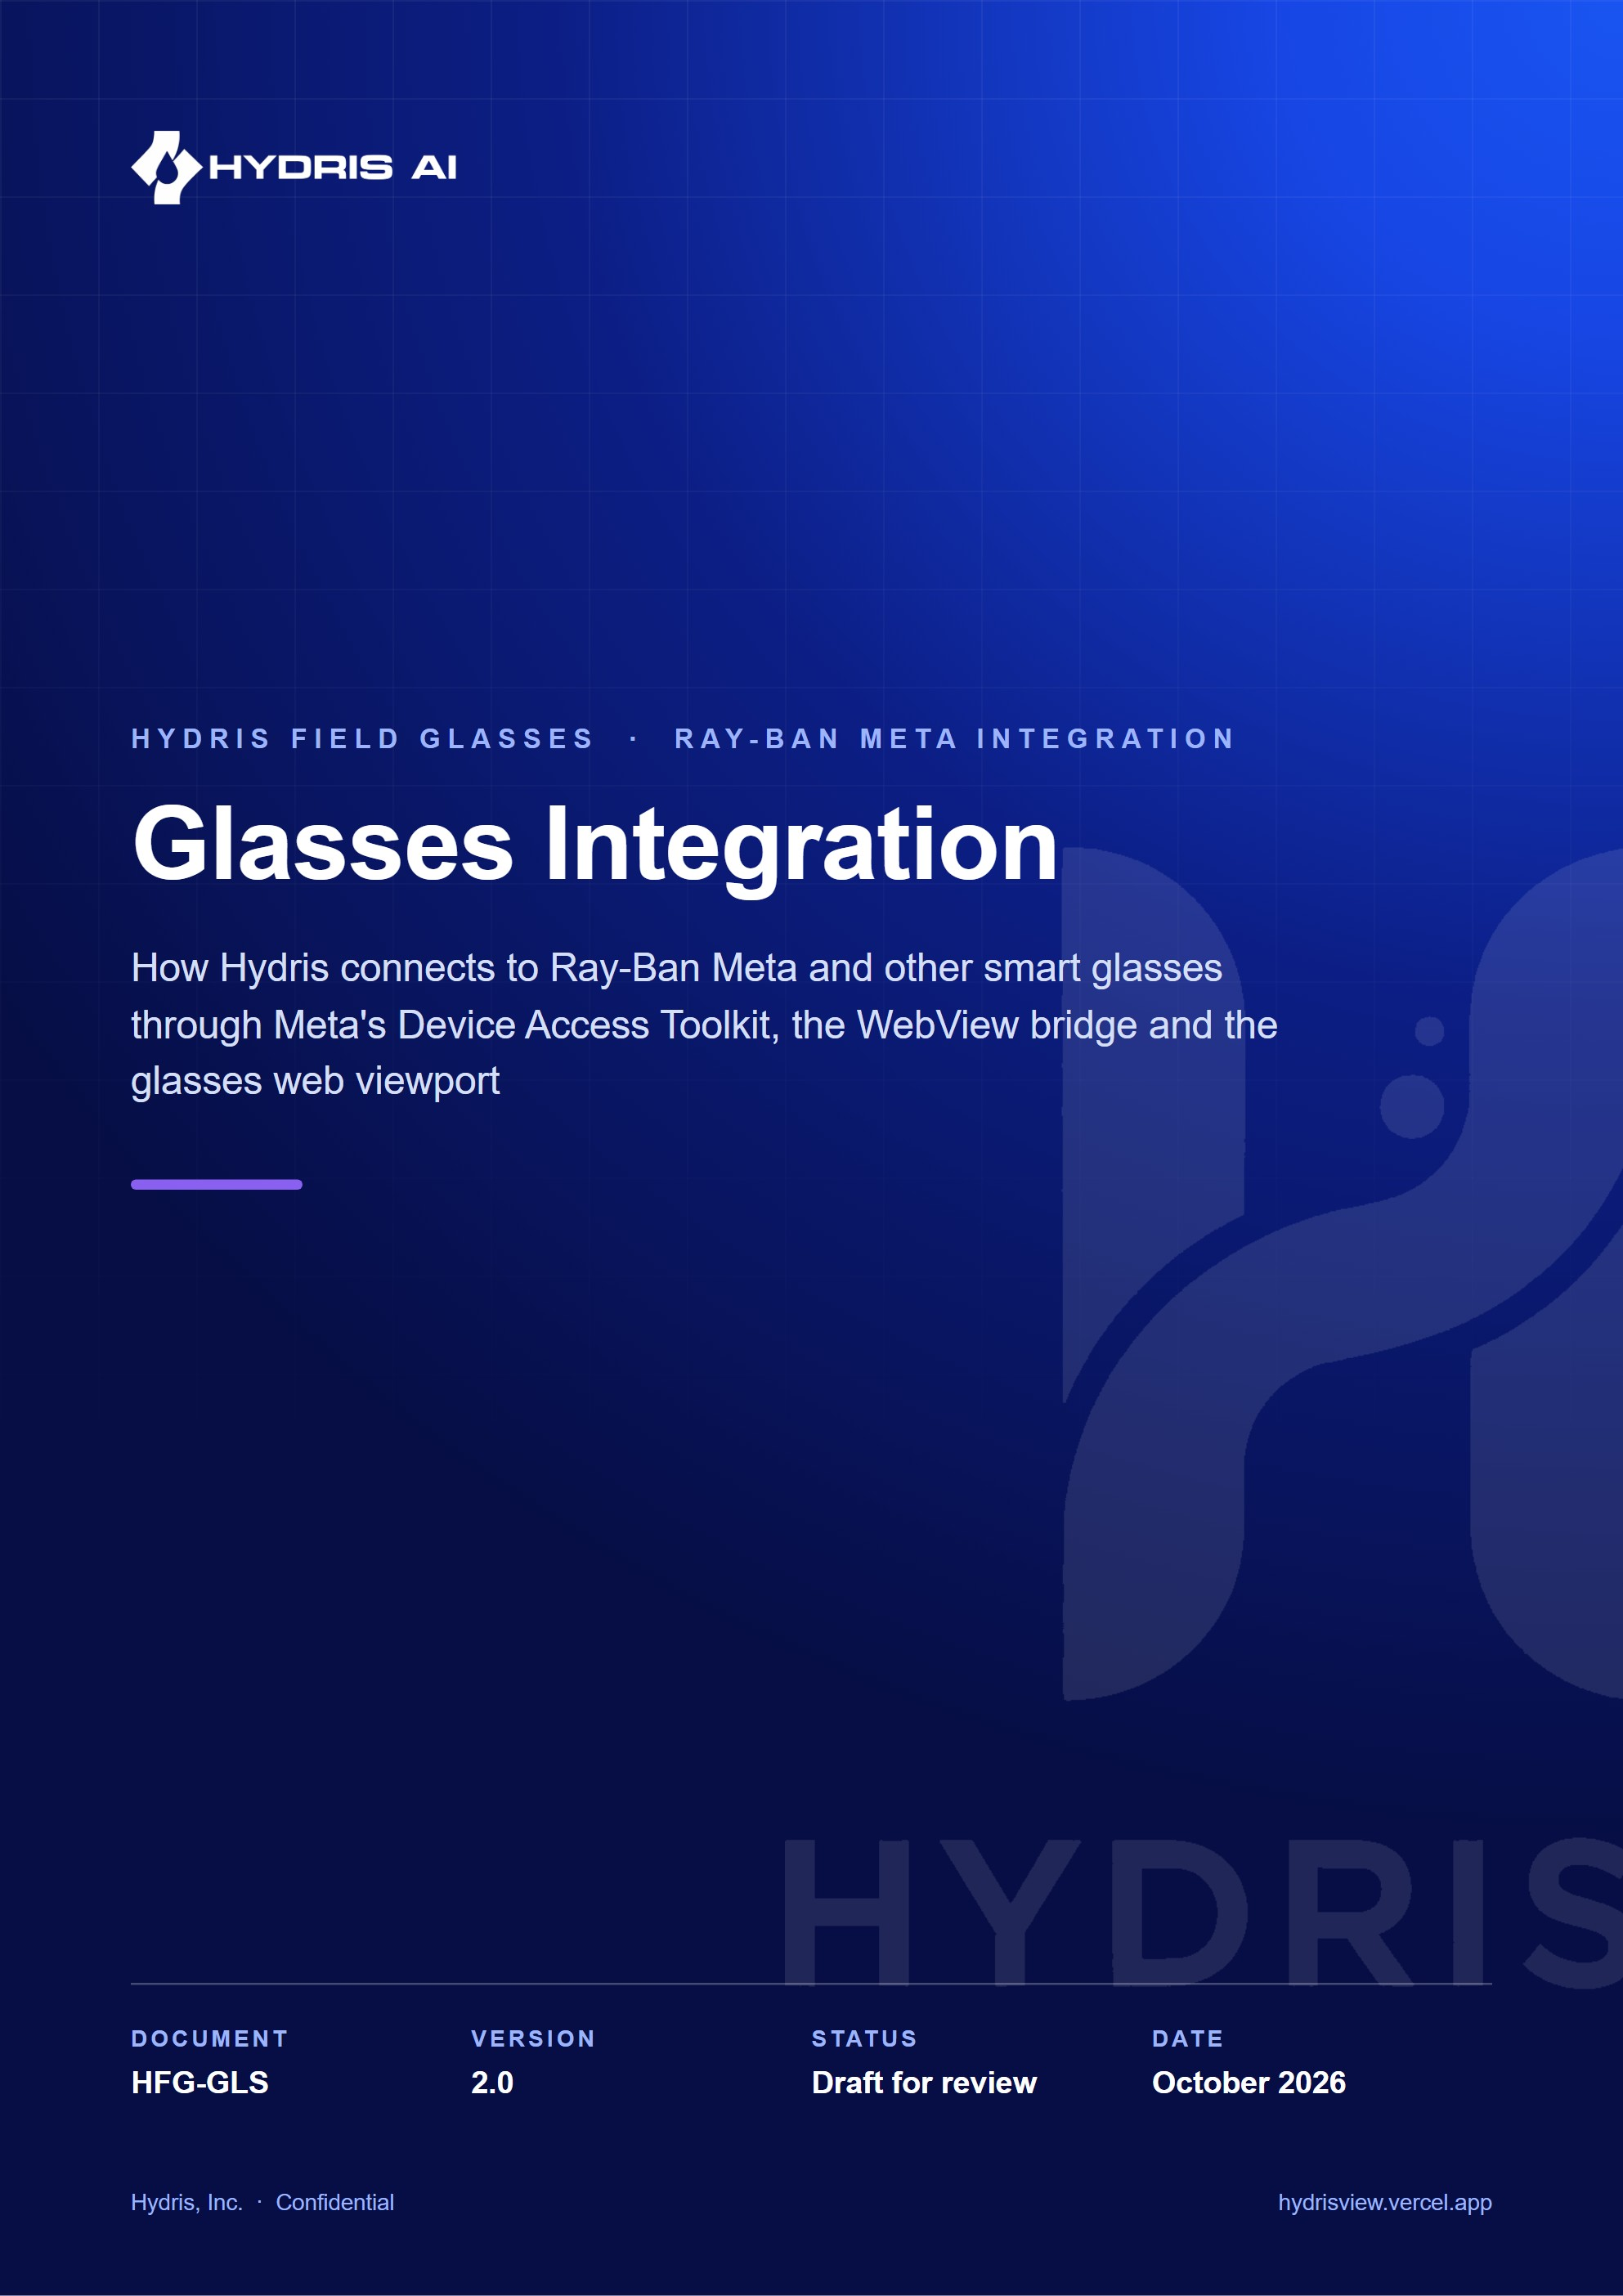
Document control
Document | Glasses Integration (HFG-GLS)
Version | 2.0
Status | Draft for review
Owner | Engineering, Hydris
Audience | Mobile, web and backend engineering, QA, solutions engineers, pilot customer IT and safety leads
Product | Hydris Field Glasses: website, operator console, glasses app, Android app, API
Source of truth | docs/product/GLASSES_INTEGRATION.md in tarun-km/hydrisview (this Word file is generated from it)
Classification | Confidential: Hydris, Inc. and named partners
Revision history
Version | Date | Author | Changes
2.0 | October 2026 | Engineering, Hydris | Rewritten against the native app, the bridge app and the glasses web viewport, with DAT lifecycle diagrams, the bridge contract, the pairing flow, setup, troubleshooting, privacy and an honest status for every claim

Contents
1 Scope and status 5
1.1 Terminology 6
2 Hardware and capabilities 7
2.1 Supported glasses 7
2.2 Display glasses from other vendors 7
3 Runtimes and architecture 9
3.1 Meta's stack 10
4 The Meta AI app dependency 12
5 DAT lifecycle 13
5.1 Initialization 13
5.2 Registration through the Meta AI app 14
5.3 Permissions 14
5.4 Session 15
5.5 Camera stream for guided capture 16
5.6 Photo capture 16
5.7 Capture button 17
5.8 Speech 19
5.9 Voice Invocations 19
5.10 Errors 19
6 Web bridge contract 21
6.1 Page to host 21
6.2 Host to page 21
6.3 Other host shapes 22
7 Glasses web viewport 25
7.1 HUD and phone modes 25
7.2 Phases and screens 27
7.3 Voice assistant on the viewport 28
7.4 Audit scan on the viewport 28
8 Pairing with the Hydris account 29
8.1 Code and QR (viewport and bridge) 29
8.2 Self-approval (native app) 29
9 Setup guide 31
9.1 Developer setup 31
9.2 Operator setup (native app) 31
10 Troubleshooting 32
11 Limitations and known gaps 33
12 Glasses state model and console view 34
12.1 GlassesState fields 34
12.2 What the console sees 34
13 Data flows and network use 36
14 Hardware acceptance tests 37
15 Frequently asked questions 38
16 Privacy 39
17 Roadmap 40

Hydris puts live plant data, guided paper capture and a voice assistant in front of field operators who need their hands free. This document explains how Hydris talks to smart glasses: which glasses, which capabilities, which software stack, and what is built, partial or planned. It covers three runtimes that share one backend and one account model:
- Hydris Field (apps/android), the native Android app, which uses Meta's Wearables Device Access Toolkit (DAT) directly.
- Hydris Glasses bridge (apps/glasses-bridge-android), a WebView host that loads the glasses web app and exposes DAT to it through a JavaScript bridge.
- The glasses web viewport (apps/web/src/glasses/*, served at /glasses), which runs as a heads-up display (HUD) in the browser simulator and as a full-screen phone layout inside the bridge.
4  DAT modules used  core, camera, speech, inputs (1.0.1) |  | 0  Displays on Ray-Ban Meta  the phone is the screen |  | 3  Camera bridge shapes  JS interface, injected API, postMessage |  | 300 s  Pairing code lifetime  `PAIRING_TTL_S`

IMPORTANT
No Hydris build has yet been run against physical Meta glasses. All DAT calls compile and are type-checked against DAT 1.0.1, and the page side of the bridge was tested end to end with a stand-in bridge (apps/glasses-bridge-android/README.md). Every hardware behaviour in this document is therefore Built, not hardware-verified unless stated otherwise. The first hardware run is the top item on the roadmap.

1 Scope and status
Table 1. Integration status at a glance
Capability | Native app | Bridge app | Web viewport alone
Register with the Meta AI app | Built | Built | Not possible
Glasses camera preview for guided A4 capture | Built | Built | Not possible
Full-resolution glasses photo | Built | Built | Not possible
Capture button | Built | Built | Keyboard and simulator only
Glasses microphone ("Hey Hydris") | Built | Built | Browser microphone
Spoken answers on the glasses speakers | Built (phone TTS over Bluetooth) | Built | Browser speech synthesis
Voice Invocations ("Hey Meta, start Hydris") | Planned | Built | Not possible
Register glasses as a Hydris device | Built (self-approved) | Built (code and QR via the viewport) | Built (code and QR)
HUD on glasses with a display | Not applicable | Not applicable | Built in the simulator; on-glasses Planned

1.1 Terminology
Table 2. Terms used in this document
Term | Meaning
DAT | Meta Wearables Device Access Toolkit: the Android and iOS SDK that lets phone apps use supported Meta glasses
Meta AI app | Meta's phone app (Android package com.facebook.stella) that pairs the glasses, updates firmware and approves third-party apps
Registration | DAT's approval that Hydris may connect to the glasses, confirmed in the Meta AI app
Session | A DAT DeviceSession with one device; camera, speech and inputs are capabilities added to it
Pairing | Hydris's own device authorization flow that turns the glasses into a Hydris device record
HUD | The 600 x 600 display layout of the web viewport
Phone mode | The full-screen phone layout of the web viewport used inside the bridge

2 Hardware and capabilities

2.1 Supported glasses
Meta's DAT FAQ lists Ray-Ban Meta (Gen 1 and Gen 2), Meta Ray-Ban Display, Oakley Meta HSTN and Oakley Meta Vanguard as supported, and says capability availability varies by device. Meta's setup guide additionally lists Ray-Ban Meta Optics and "Meta glasses". Hydris's primary target is Ray-Ban Meta Gen 2.
Table 3. Capability matrix by glasses family
Capability | Ray-Ban Meta (Gen 1, Gen 2) | Oakley Meta (HSTN, Vanguard) | Meta Ray-Ban Display | Browser simulator
Supported by DAT | Yes (Meta FAQ) | Yes (Meta FAQ) | Yes (Meta FAQ) | Not applicable
Camera stream and photo to the phone app | Yes via DAT | Yes via DAT, unverified by Hydris | Yes via DAT, unverified by Hydris | Simulated camera
Microphone and speech | Yes via DAT Speech | Unverified by Hydris | Unverified by Hydris | Web Speech API
Open-ear speakers | Phone TTS over Bluetooth | Phone TTS over Bluetooth | Phone TTS over Bluetooth | speechSynthesis
Capture button input | DAT Inputs | Unverified by Hydris | Unverified by Hydris | Keyboard, hydris:input
Display | None | None | Yes | 600 x 600 HUD
Hydris UI | On the phone | On the phone | On the phone today; on-glasses Planned | HUD
Hydris status | Primary target, not yet run on hardware | Expected to work, untested | Phone path expected to work; display Planned | Built

NOTE
Vendor hardware figures (camera megapixels, battery life, microphone count) are deliberately not quoted here. Take them from Meta's current specification sheets when talking to customers.

2.2 Display glasses from other vendors
The console's demo data (apps/api/src/seed/showcase.ts) contains device records for Vuzix M400 and RealWear Navigator 520 units, plus a browser simulator. These records show how a fleet of display glasses appears in the console (status, firmware, app version, assignment). Hydris has no native app for Vuzix or RealWear yet. The web viewport is designed for such devices: a 600 x 600 additive display, large type and directional input. The simulator offers 600 x 600, 640 x 480 and 480 x 480 viewports (apps/web/src/app/simulator/page.tsx).
Table 4. Other display glasses
Device | Where it appears | Status
Vuzix M400 | Demo device records | Planned: run /glasses in the device browser or a thin Android host; not tested
RealWear Navigator 520 | Demo device records | Planned: as above, with voice-first navigation; not tested
Browser simulator | /simulator, device kind simulator | Built

3 Runtimes and architecture
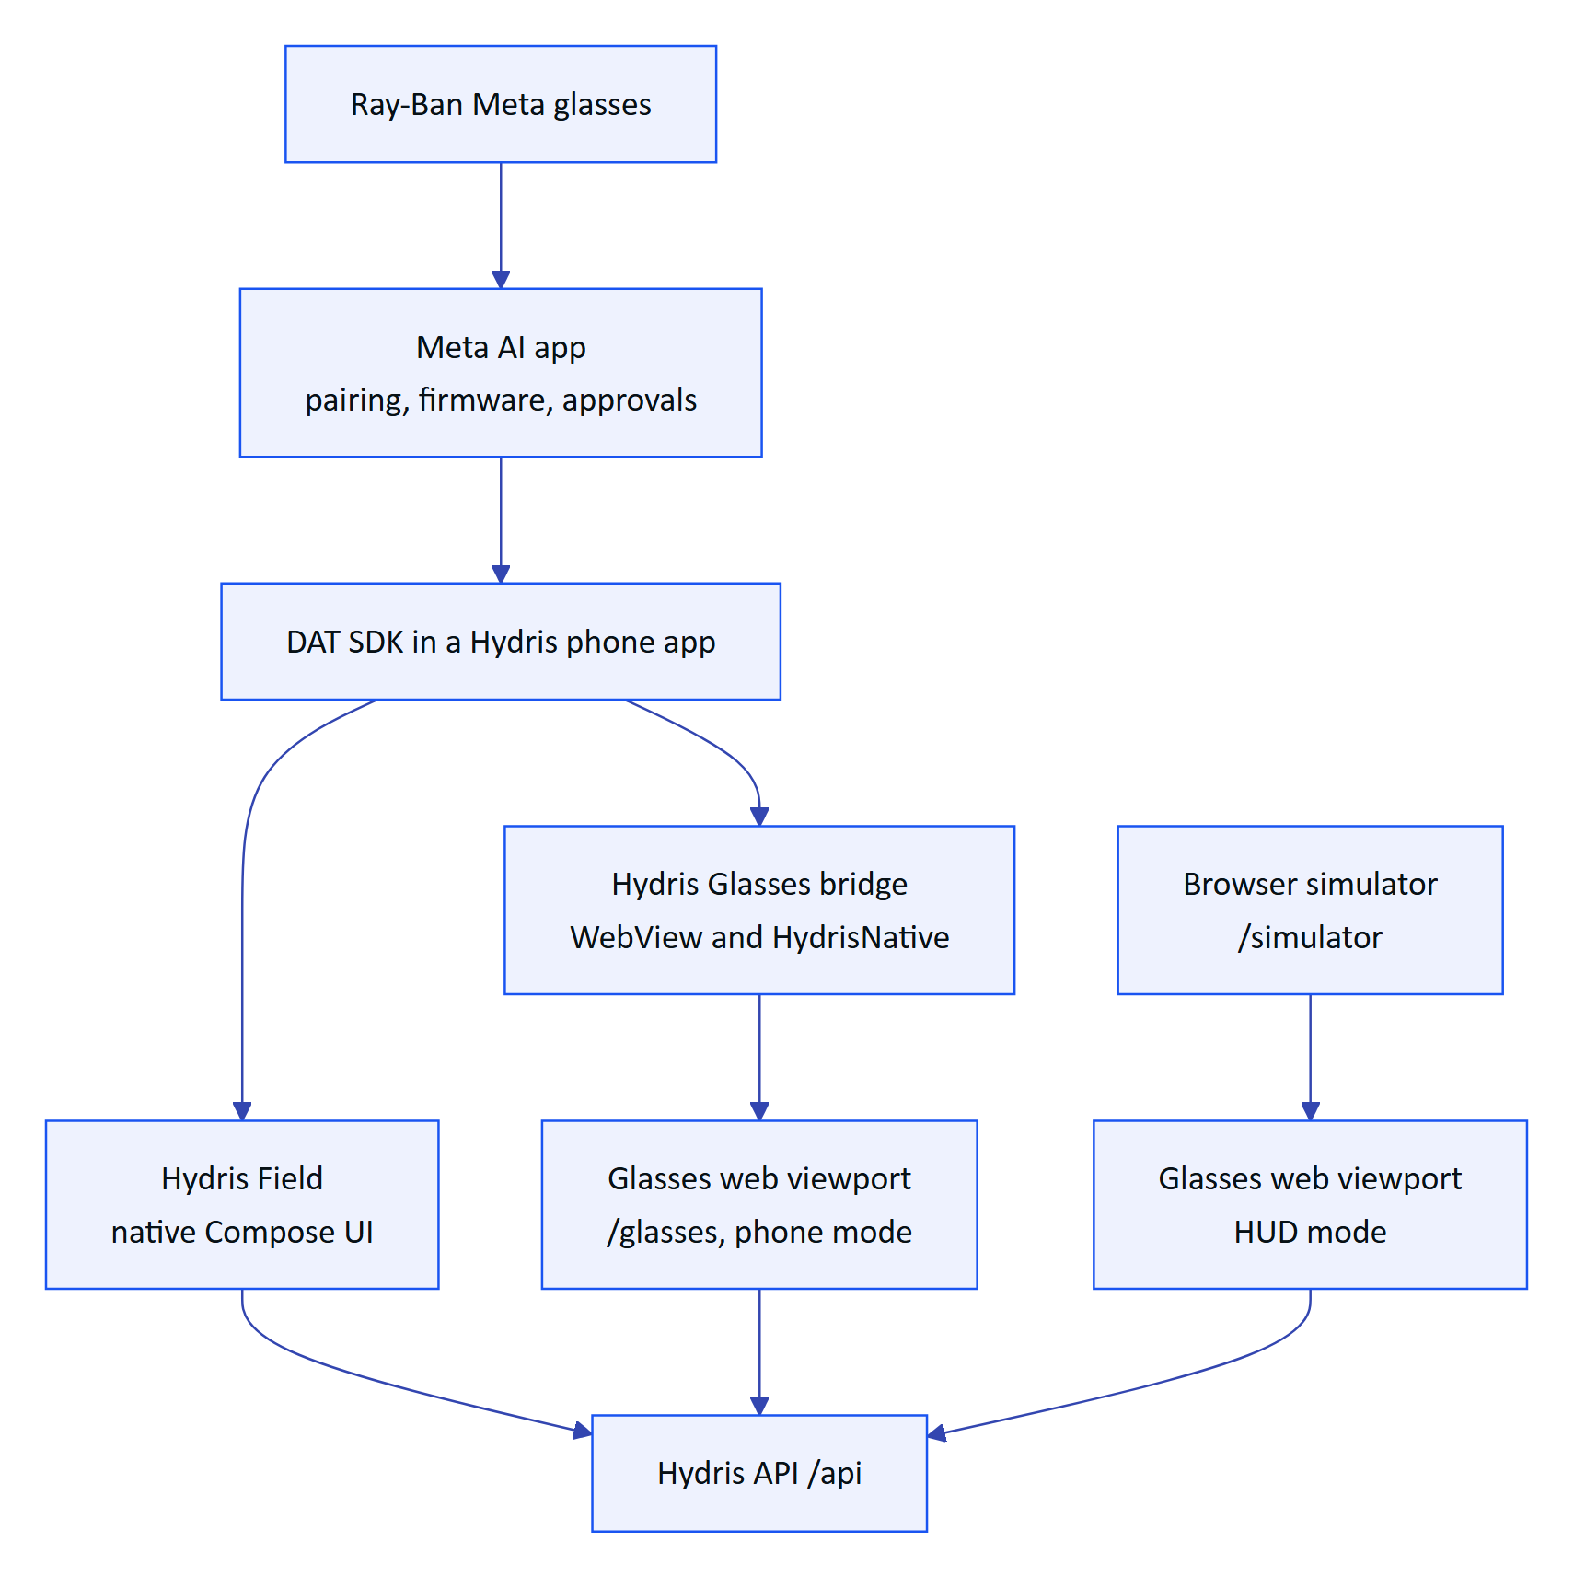
Figure 1. The three glasses runtimes and the shared Hydris backend

3.1 Meta's stack
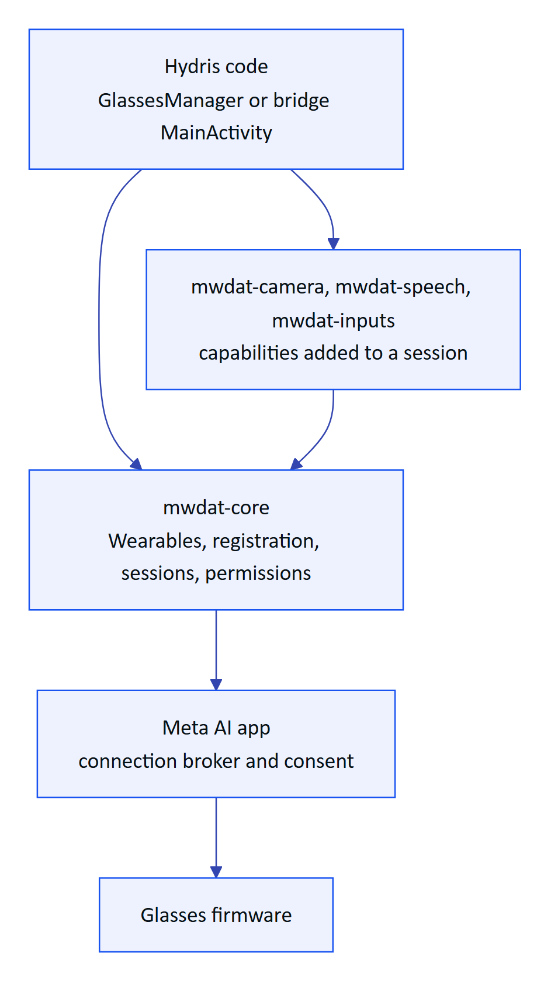
Figure 2. Layers between Hydris code and the glasses
Table 5. DAT artifacts used (com.meta.wearable, version 1.0.1)
Artifact | What Hydris uses
mwdat-core | Wearables.initialize, registrationState, registrationErrorStream, startRegistration, startUnregistration, devices, devicesMetadata, checkPermissionStatus, RequestPermissionContract, createSession(AutoDeviceSelector()), isVoiceInvocationsIntent
mwdat-camera | session.addCamera(StreamConfiguration(VideoQuality.MEDIUM, 24)), stream.videoStream, stream.start, stream.state, stream.capturePhoto, PhotoData.Bitmap and PhotoData.HEIC
mwdat-speech | session.addSpeech(), transcriptions, state, errors, start, stop
mwdat-inputs | session.addInputs(InputsConfiguration(CAPTURE_BUTTON)), InputEvent.Capture with CapturePressType.SHORT_PRESS
mwdat-mockdevice | Debug dependency only; not yet used by tests

The bridge README notes that Speech, Inputs and Voice Invocations are experimental in DAT and must be enabled for the app in the Wearables Developer Center. Hydris treats them as optional at runtime: failures are logged and the phone fallbacks remain.

4 The Meta AI app dependency
Meta's documentation is explicit: "the Meta AI app must be used to pair your glasses". Developer Mode, which lets an unpublished app connect, is enabled in the Meta AI app (Settings, App Info, tap the app version five times, then turn on Developer Mode); connected apps then appear under Meta AI settings, App connections, Developer mode apps. Firmware versions must meet DAT's version dependency table, and firmware is updated through the Meta AI app.
DECISION
Hydris does not attempt to replace the Meta AI app. It must stay installed and signed in. Hydris checks for it (GlassesManager.metaAiInstalled() looks up com.facebook.stella, declared in the manifest <queries>) and tells the user to install it and pair the glasses there first.

Developer Mode builds use the manifest placeholders mwdat_application_id = "0" and mwdat_client_token = "0" (both apps' build.gradle.kts). DAT logs that it read no credentials, which is expected. Production builds put the values issued by the Wearables Developer Center in local.properties.

5 DAT lifecycle
The native GlassesManager and the bridge's MainActivity implement the same lifecycle. Differences are noted where they matter.

5.1 Initialization
DAT is initialized only after Android grants the Bluetooth permissions. The native app requests BLUETOOTH, BLUETOOTH_CONNECT and POST_NOTIFICATIONS on every onStart and initializes when BLUETOOTH_CONNECT is not denied. The bridge requests BLUETOOTH, BLUETOOTH_CONNECT and INTERNET and initializes only if all are granted.
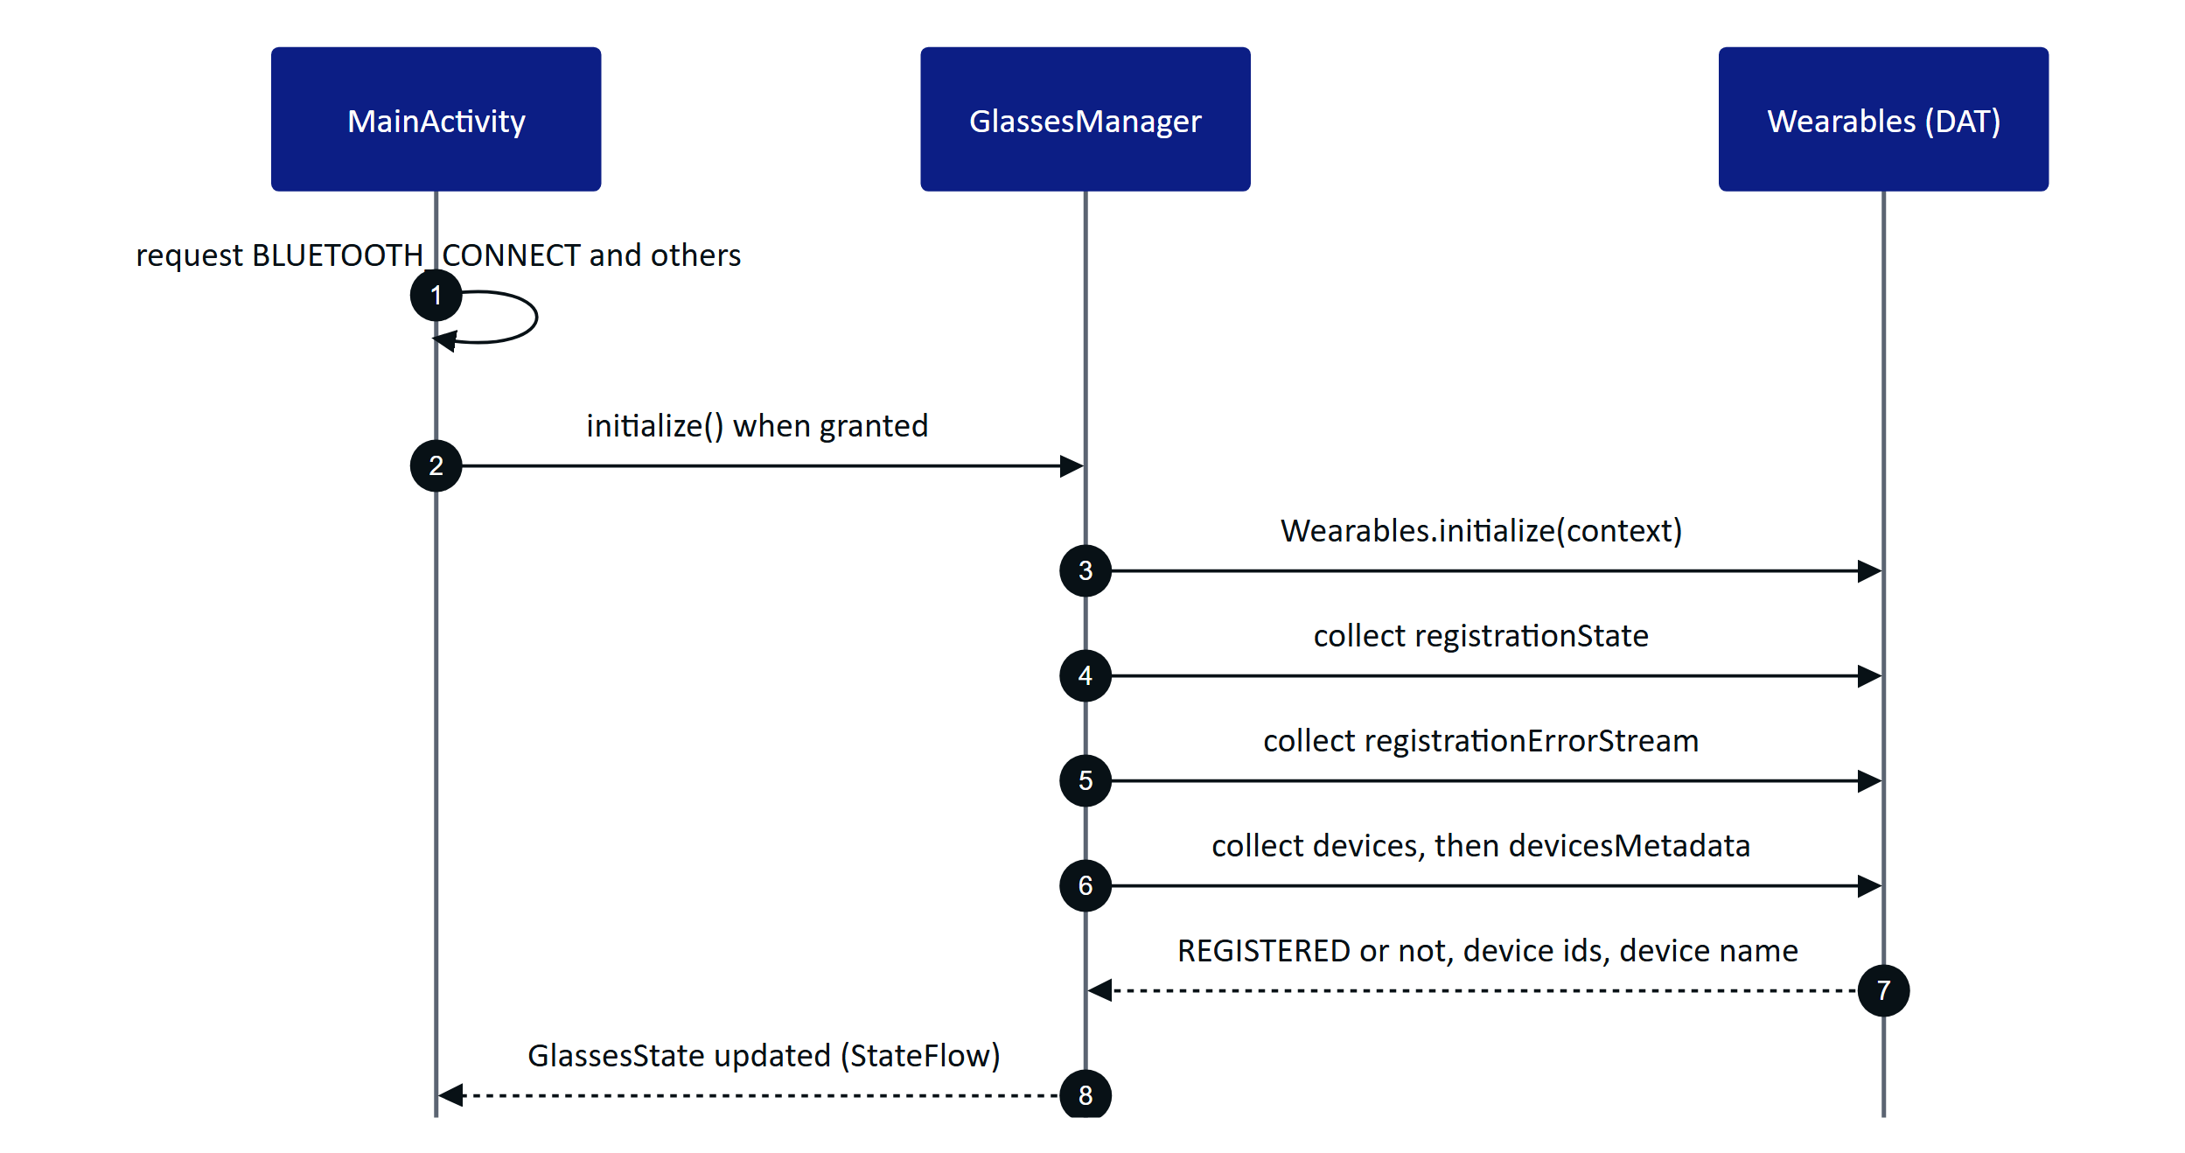
Figure 3. DAT initialization in the native app
The device name comes from devicesMetadata and falls back to "Ray-Ban Meta" when empty. The state holds the registration state, the device list, the session state, camera streaming, speech state, the last error and a log of the latest 30 messages.

5.2 Registration through the Meta AI app
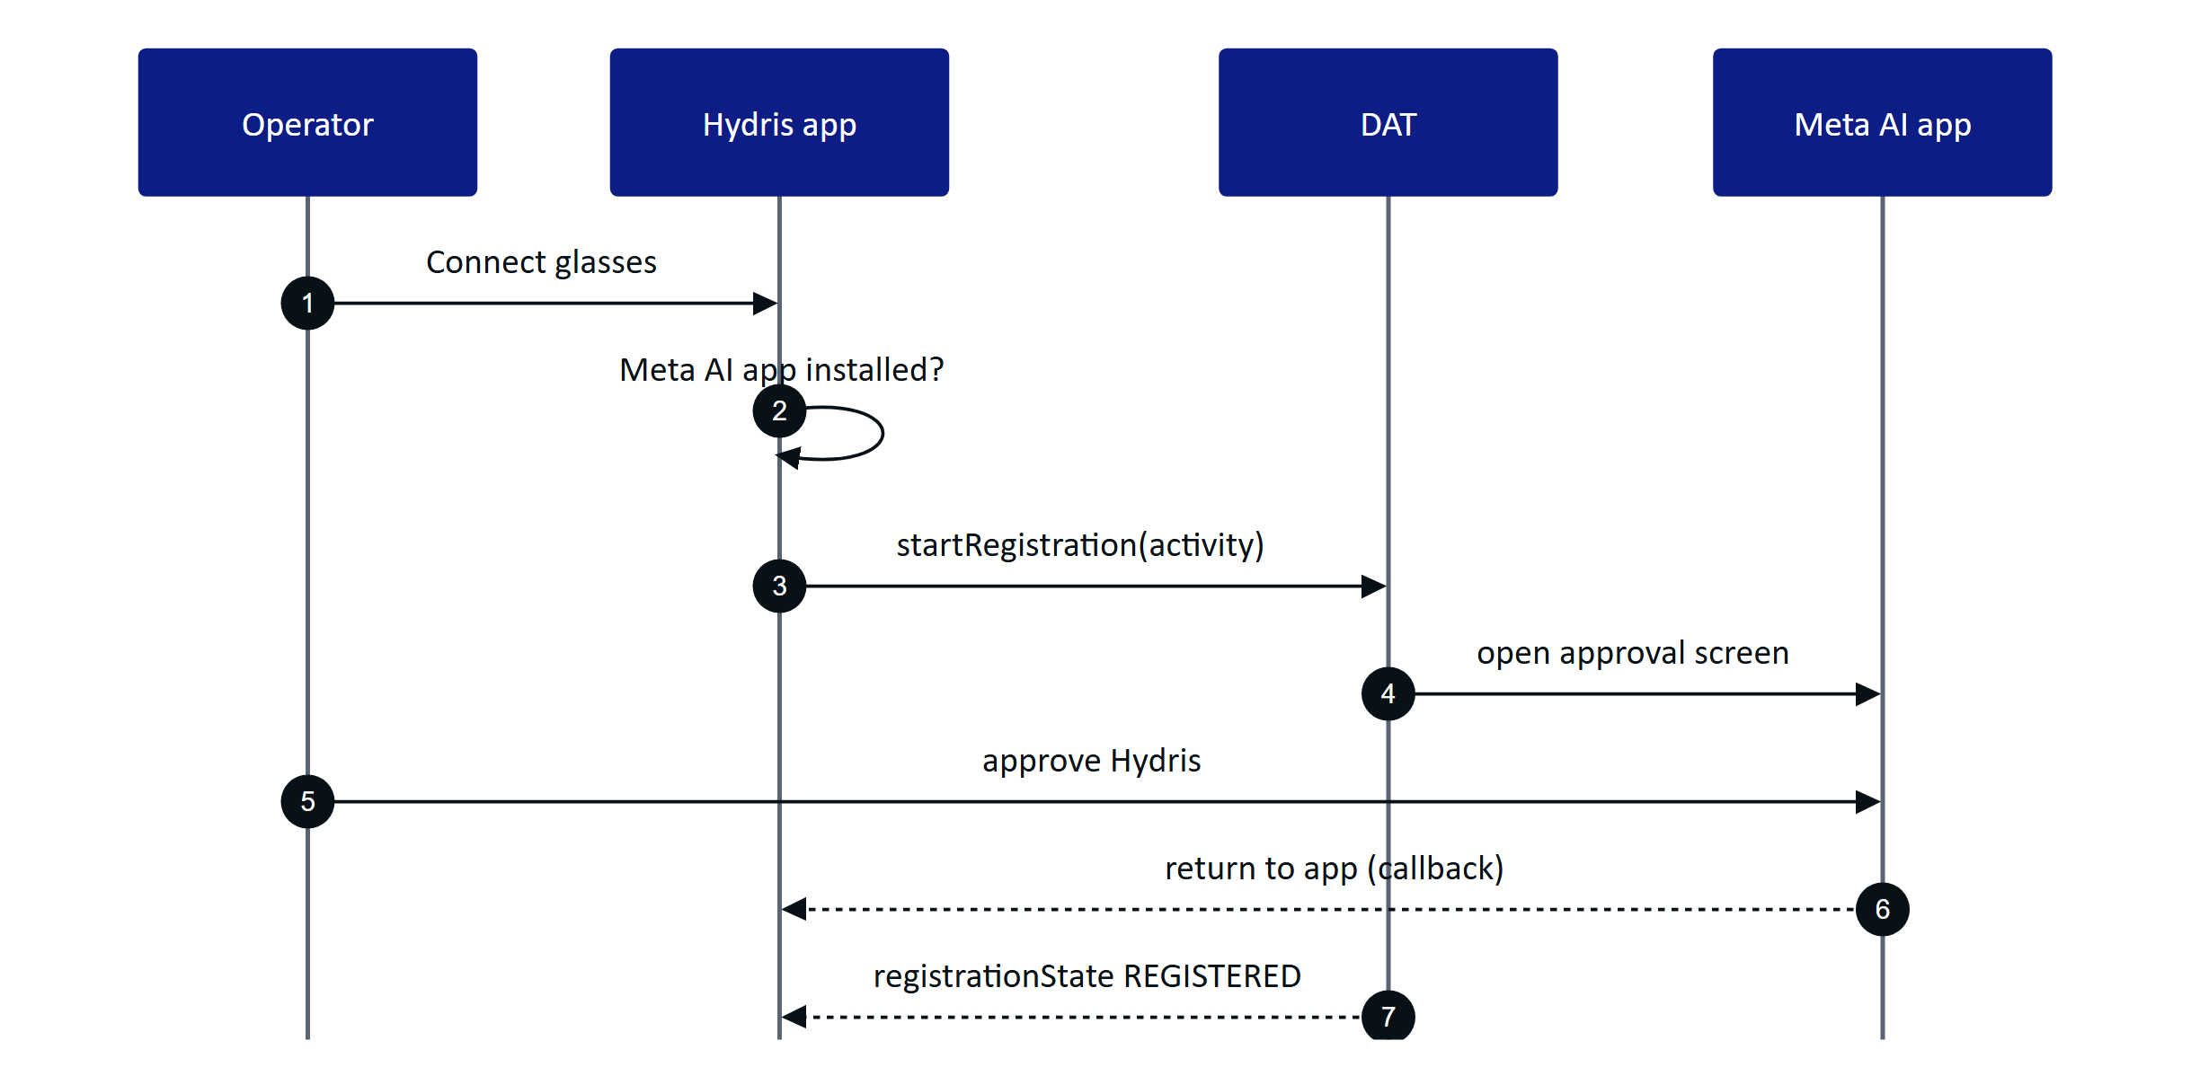
Figure 4. Registration hands off to the Meta AI app and returns
Each app declares a callback URL scheme in its manifest for the return from the Meta AI app: hydrisfield for the native app and hydrisglasses for the bridge. The native app starts registration only from the Glasses screen. The bridge also starts it automatically when the page needs a session and the app is not registered, and exposes HydrisNative.connectGlasses(). Unregistration uses startUnregistration (native "Disconnect").

5.3 Permissions
Camera and microphone access on the glasses are DAT permissions, separate from Android permissions, and are approved in the Meta AI app.
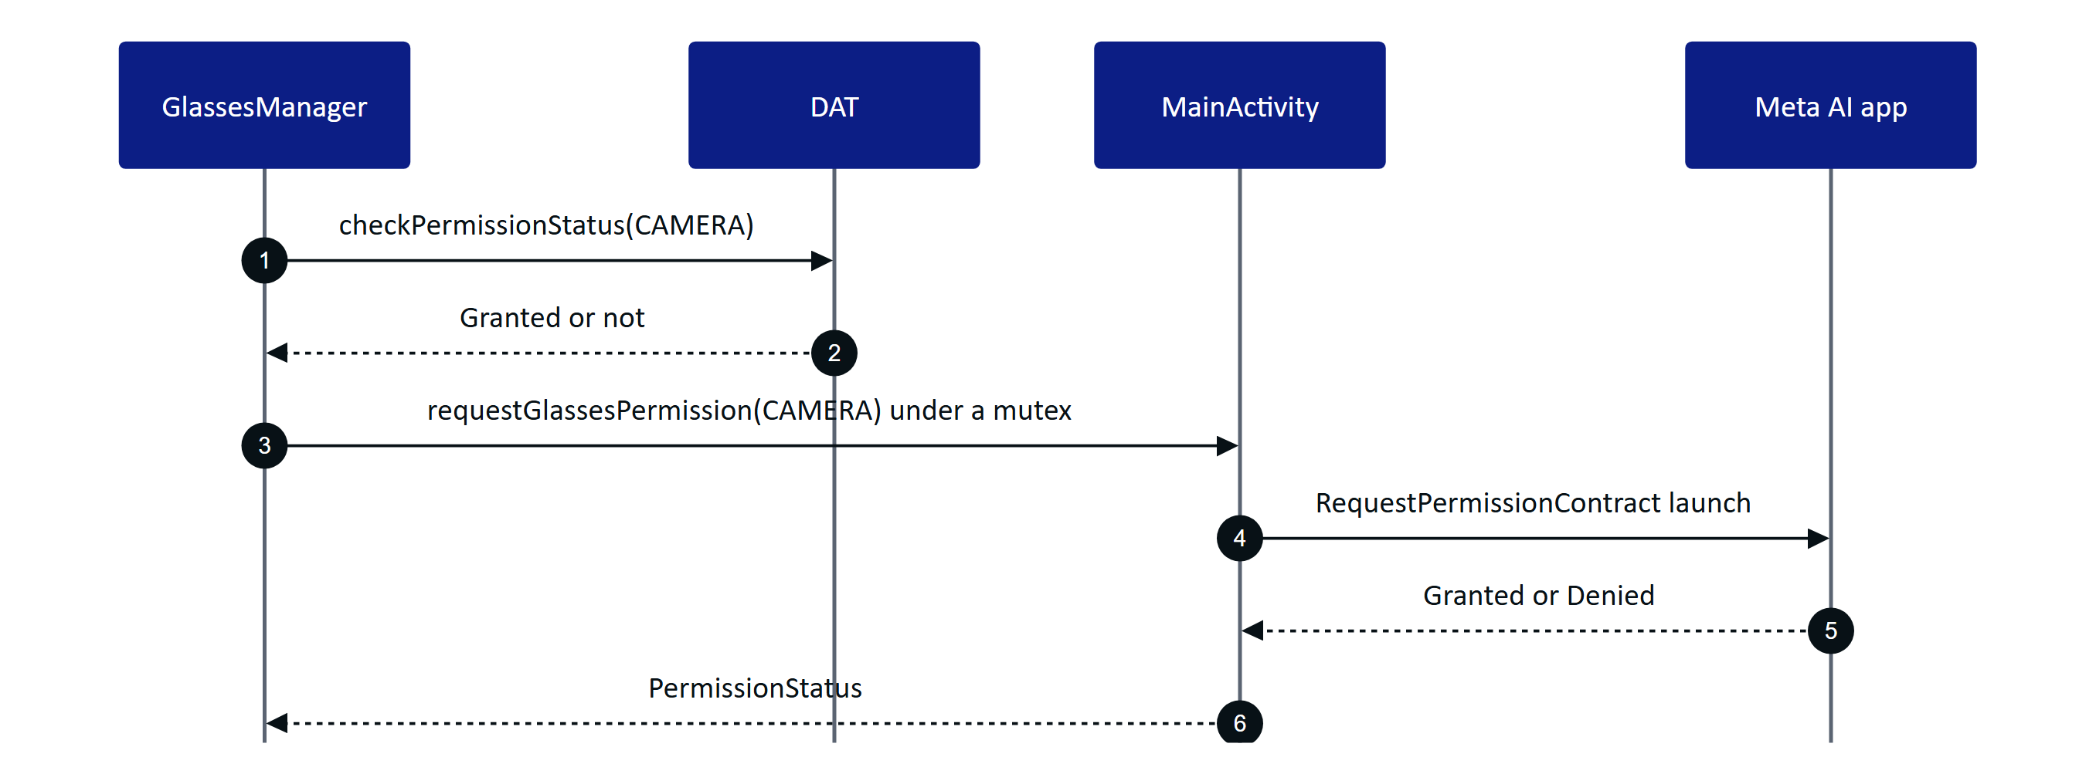
Figure 5. Requesting a glasses permission
The mutex ensures only one prompt is open at a time. A cancelled or failed result is treated as Denied.

5.4 Session
One DeviceSession is shared by camera, speech and inputs. It is created lazily with createSession(AutoDeviceSelector()) the first time a capability is needed, started, and reused while its state is STARTED. A CompletableDeferred lets concurrent callers wait for the same session.
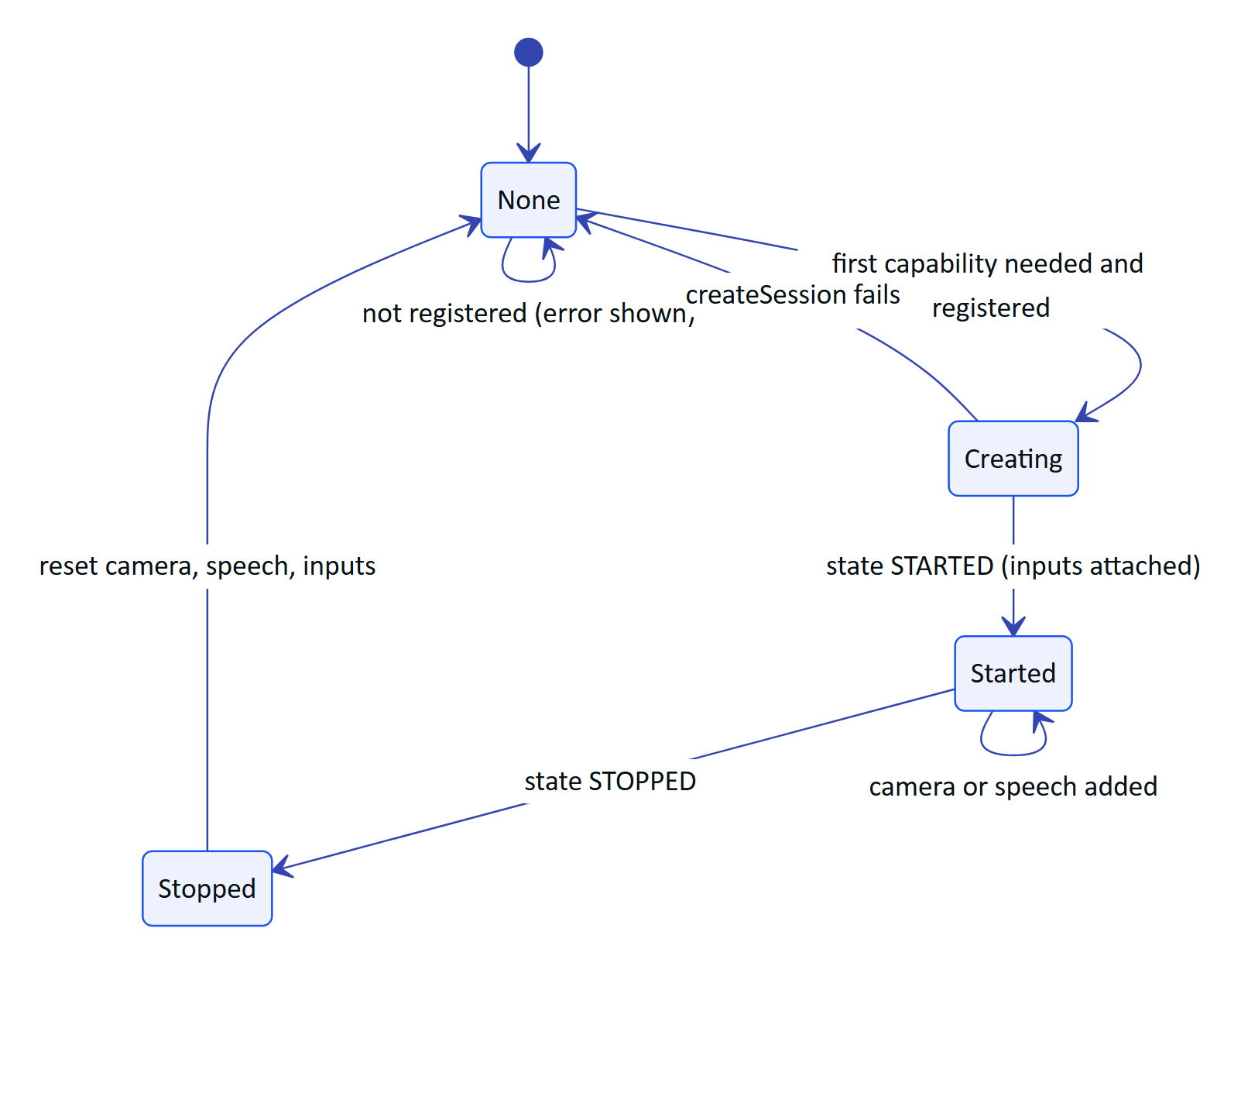
Figure 6. Device session lifecycle
On STOPPED both apps drop the camera, speech and inputs objects so the next request creates a fresh session. Session errors are logged ("Session: ...").

5.5 Camera stream for guided capture
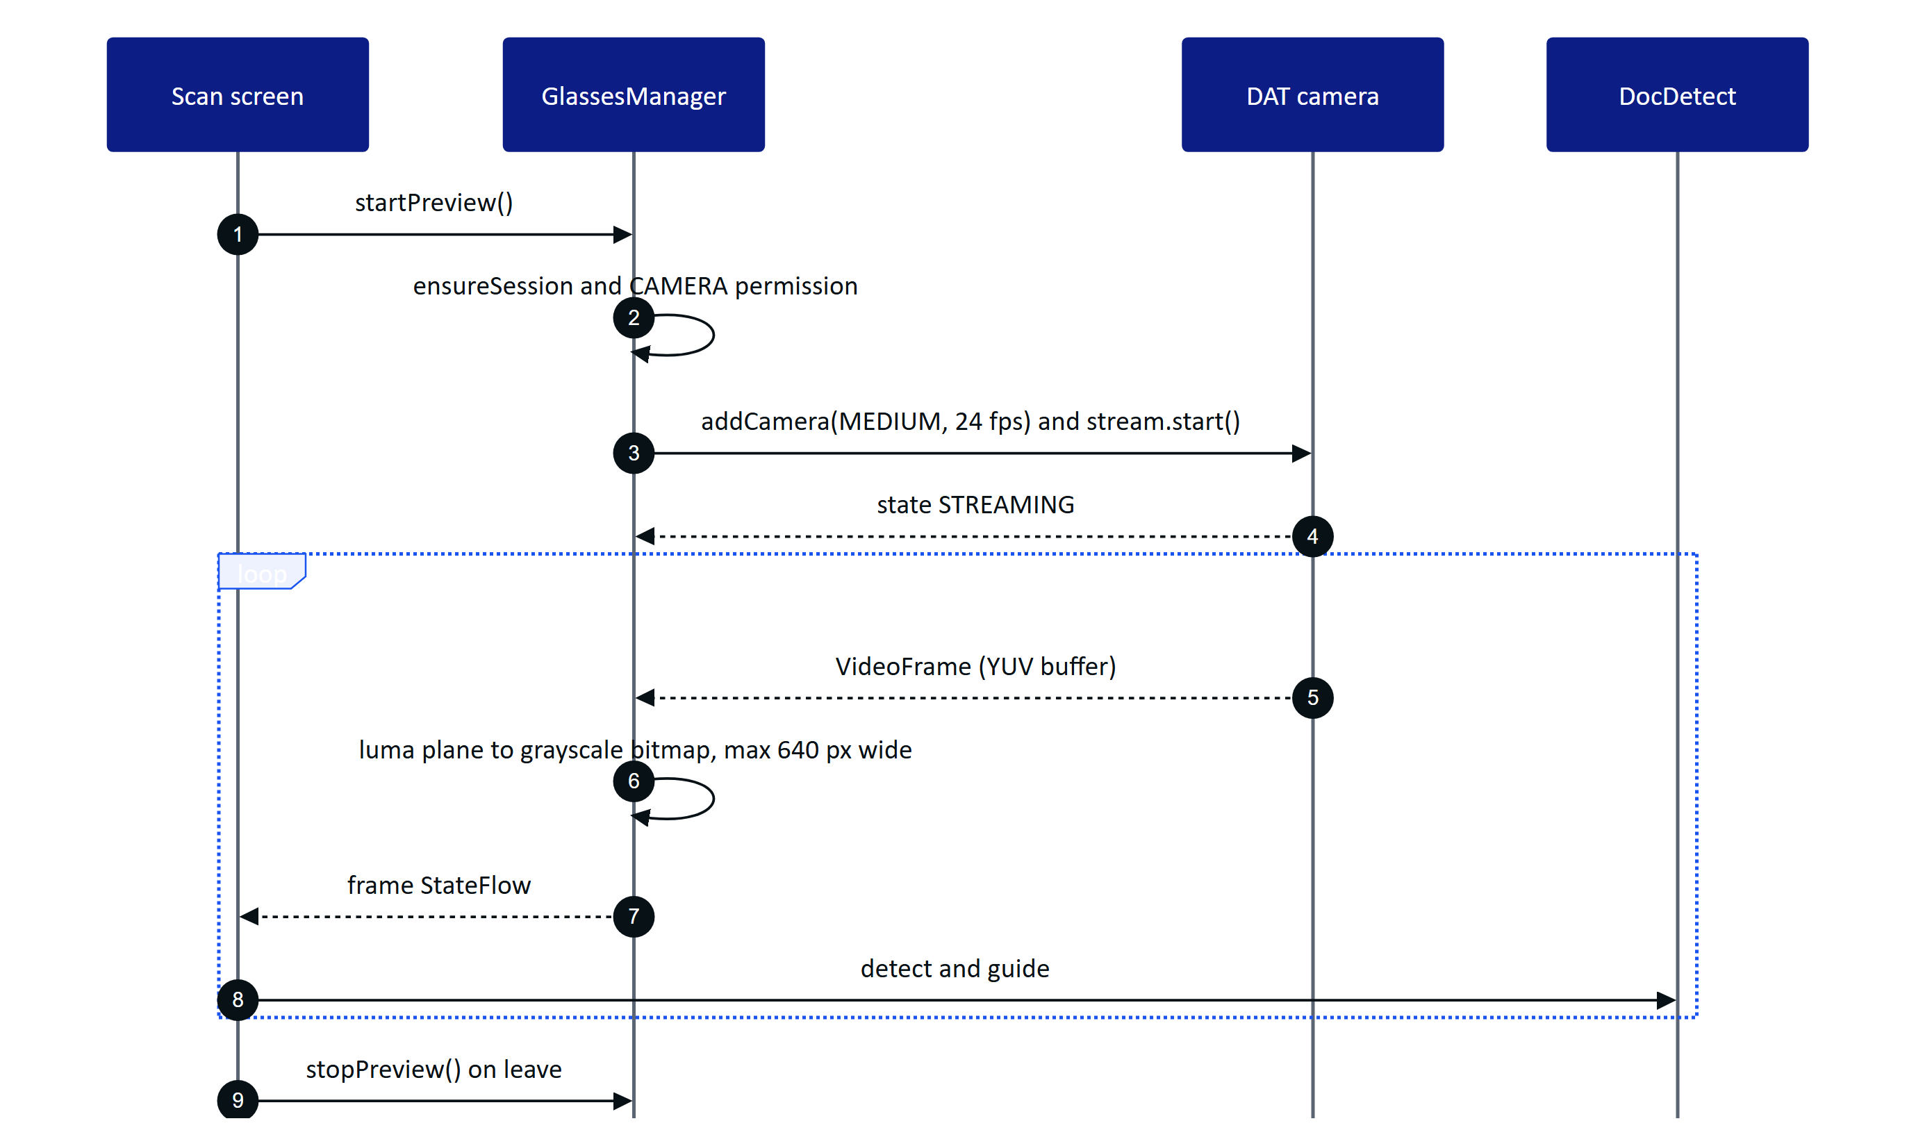
Figure 7. Glasses preview frames feeding page detection
DAT documents raw frames as YUV pixel data without fixing the chroma layout. Every planar or semi-planar 4:2:0 layout starts with the full-resolution luma plane, so Hydris reads luma only. The row stride is inferred from the buffer size (total bytes over height times 1.5), and frames are subsampled to at most 640 px wide. Compressed frames are skipped. The native app forwards at most one frame per 100 ms; the bridge encodes one JPEG (quality 70) per 120 ms and calls window.__hydrisCameraFrame.
RISK
Two parts of this path are unverified on hardware: stride inference, and the battery cost of the stream. stopPreview() stops forwarding frames but does not stop the DAT stream, which ends only with the session. Stopping the stream explicitly is Planned and must be checked against the capture LED behaviour.

5.6 Photo capture
capturePhoto() works only on an active stream, so both apps wait until the stream reports STREAMING (or stops) before capturing.
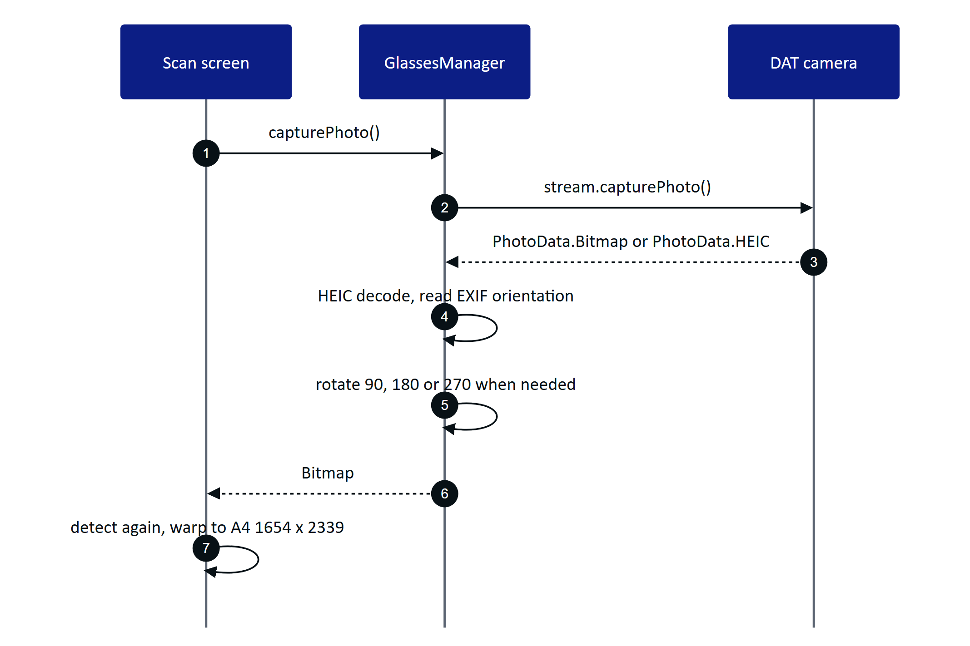
Figure 8. Full-resolution photo from the glasses
The bridge also handles EXIF flips and transposes, then encodes the photo as JPEG at quality 92 and calls window.__hydrisCameraPhoto(requestId, base64). The native app handles rotations only; adding flips is Planned.

5.7 Capture button
When a session starts, both apps add the Inputs capability with sources = {CAPTURE_BUTTON} and consumeBack = false. Only InputEvent.Capture with SHORT_PRESS is used.
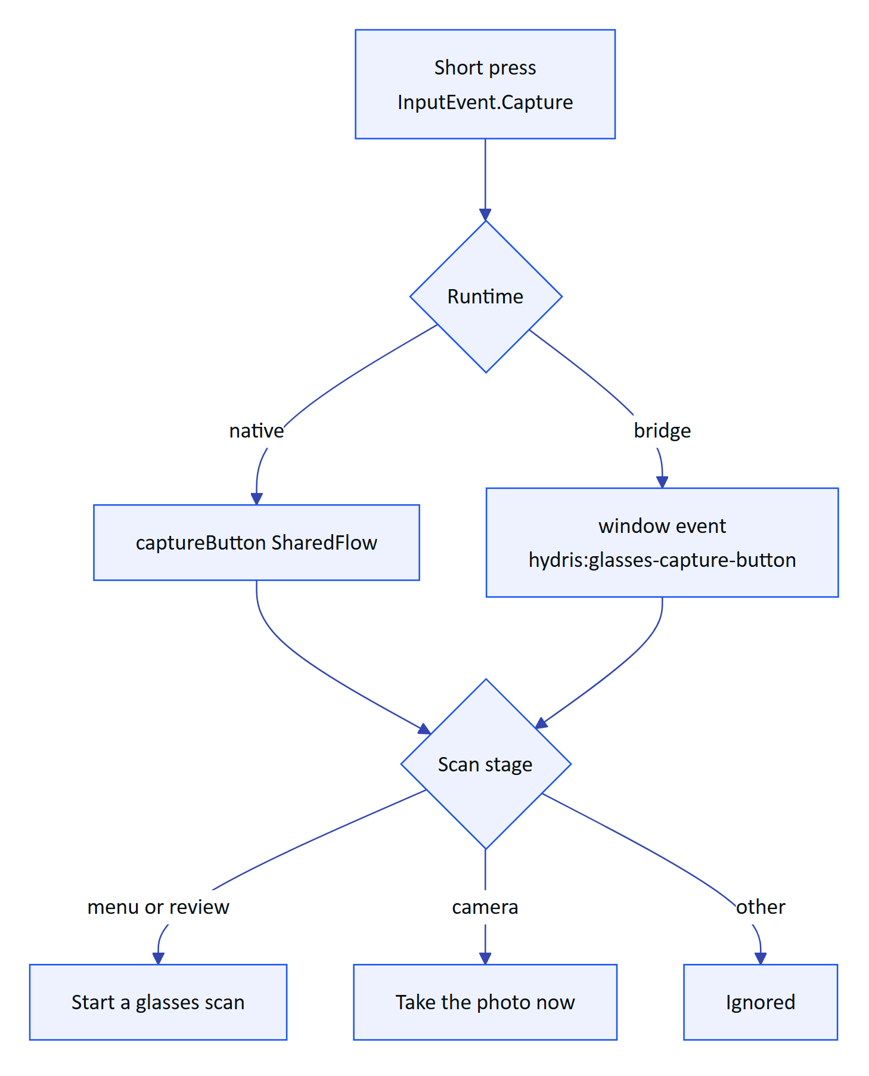
Figure 9. What a short press of the capture button does
The capture press decomposition (which presses DAT reports as short) is unverified on hardware.

5.8 Speech
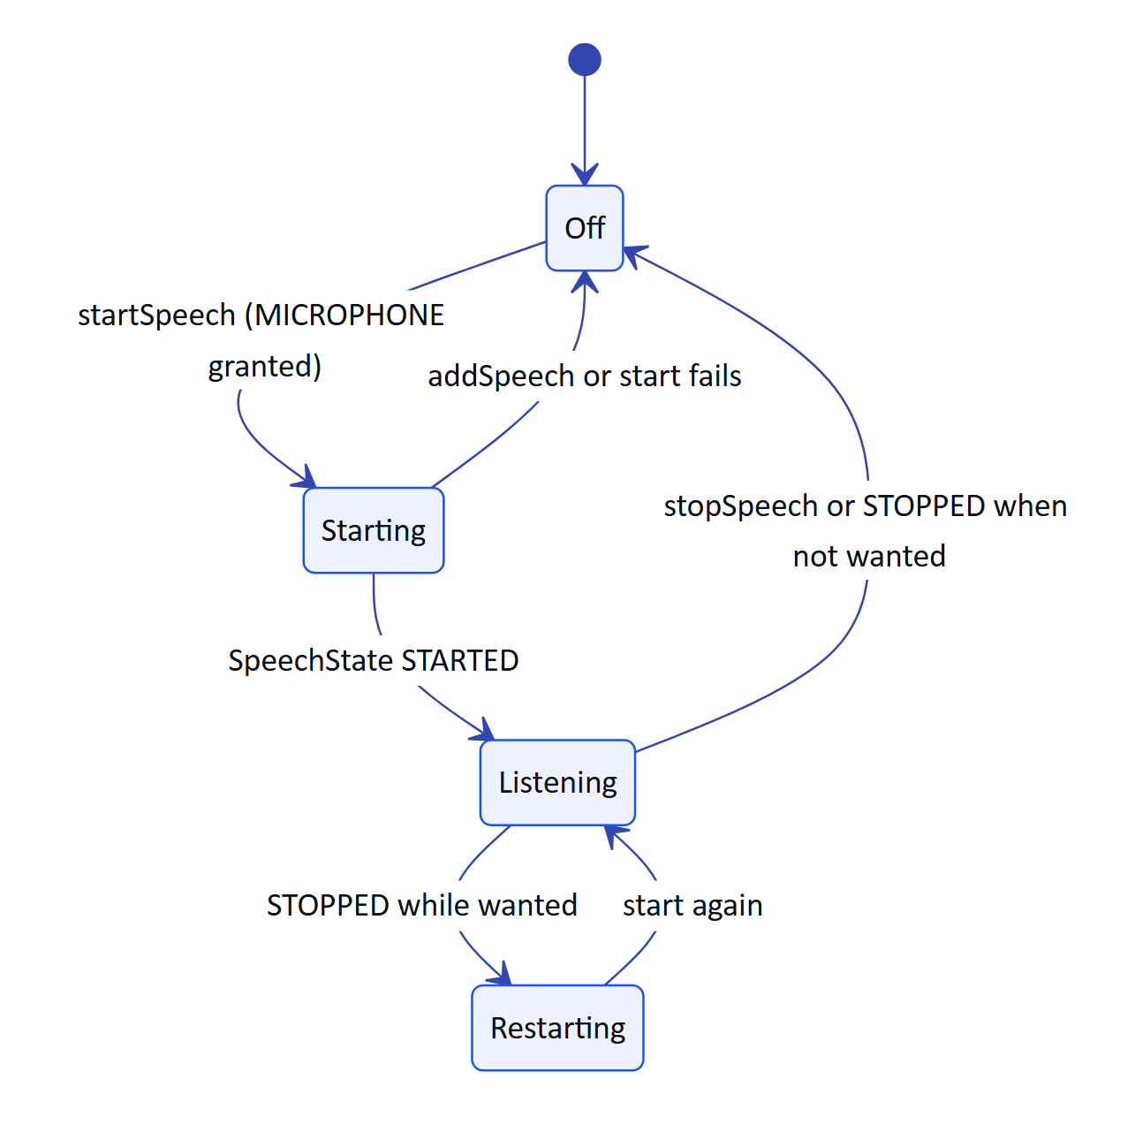
Figure 10. Always-on glasses speech with restart after silence
Transcriptions arrive as text with an isFinal flag. The native VoiceEngine drops them while text-to-speech is playing. The bridge forwards them with window.__hydrisSpeech(text, isFinal) and reports states with window.__hydrisSpeechState(state, detail). Answers are spoken by the phone's TextToSpeech; Android plays them on the glasses when they are the Bluetooth audio output.

5.9 Voice Invocations
The bridge checks every launch and new intent with isVoiceInvocationsIntent(intent) and, when it matches, dispatches hydris:voice-activate to the page, which opens the assistant. The native app does not handle Voice Invocations yet (Planned).

5.10 Errors
Table 6. Error sources and handling
Source | Example message | Handling
Registration | "Meta AI: ..." | Shown on the Glasses screen
Missing Meta AI app | "Install the Meta AI app and pair your glasses in it first" | Registration not started
Not registered | "Connect Hydris in the Meta AI app first" | No session created
Session | "No glasses session: ..." | Deferred fails, next call retries
Camera permission | "Camera permission denied in Meta AI" | Preview and capture fail; phone camera still available
Camera stream | "Stream failed: ..." | Logged; scan shows the error
Microphone permission | "Microphone permission denied in Meta AI" | Phone microphone used instead
Inputs | "Capture button unavailable: ..." | Logged only

6 Web bridge contract
The bridge app (ai.hydris.glassesbridge, version 0.2.0, minSdk 31) loads ${HYDRIS_URL}/glasses in a WebView with JavaScript and DOM storage enabled and adds a HydrisNative JavaScript interface. The page detects the bridge and switches to phone mode.
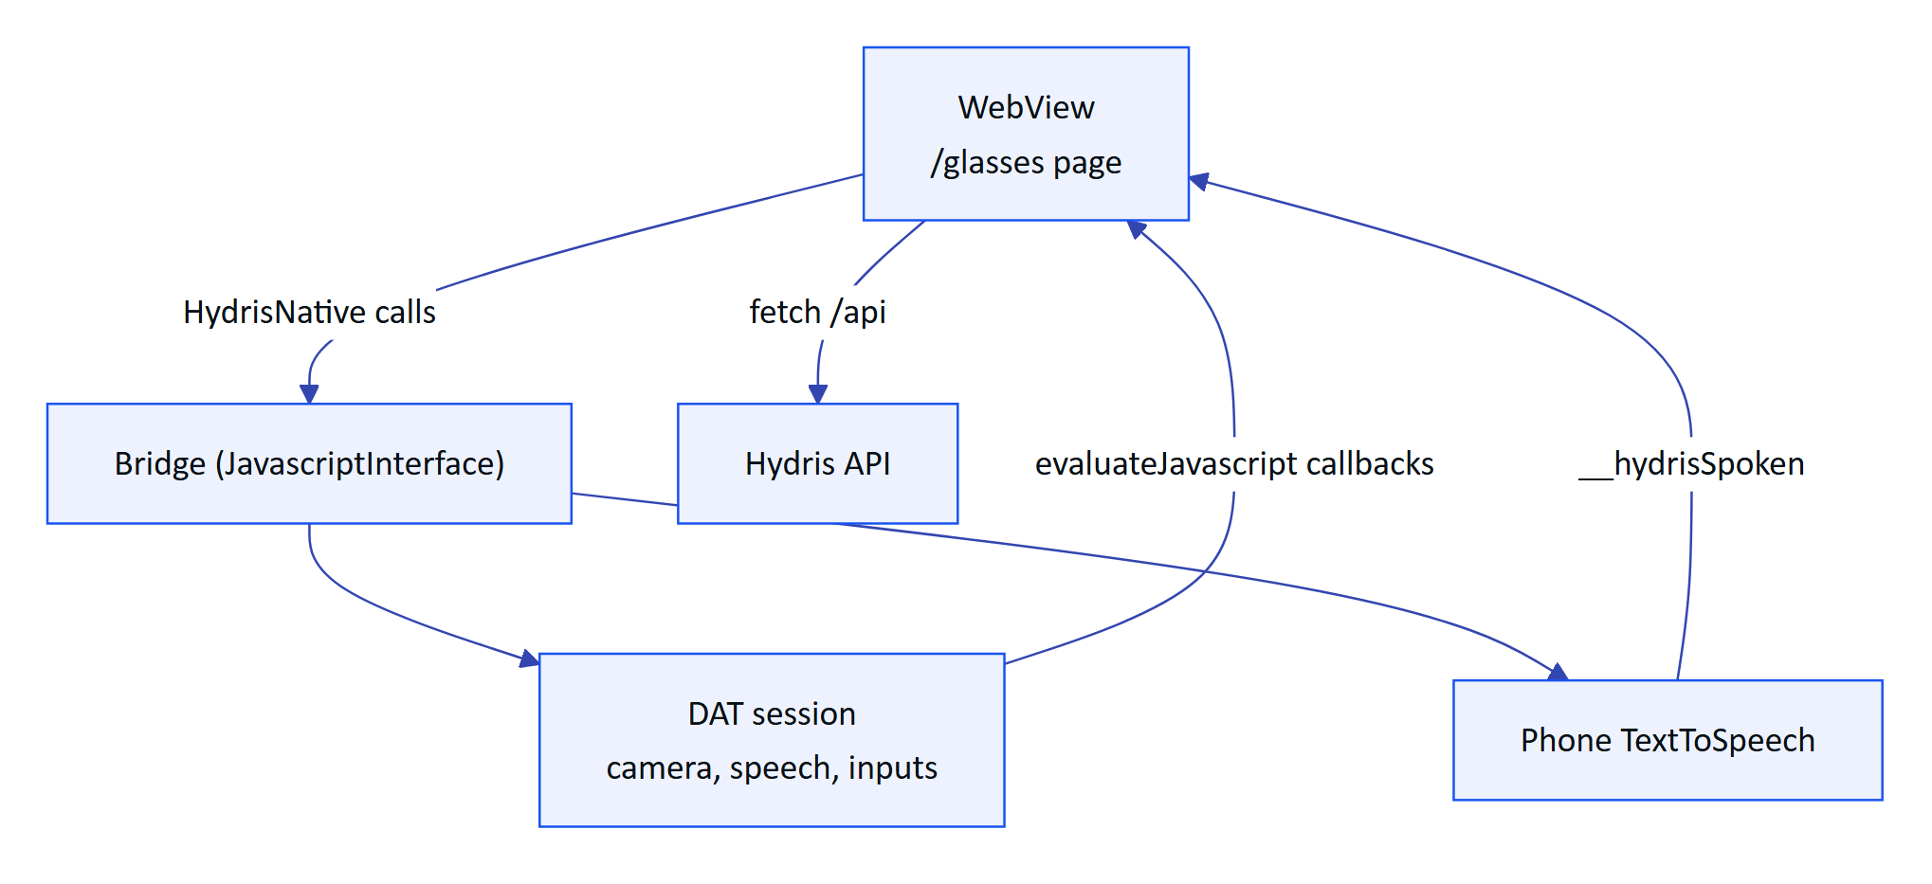
Figure 11. Bridge app structure

6.1 Page to host
Table 7. window.HydrisNative methods
Method | Effect
startPreview() | Turn preview forwarding on and ensure the camera stream
stopPreview() | Stop forwarding preview frames
capturePhoto(requestId) | Take a full-resolution photo and answer with the same ID
deviceName() | Returns "Ray-Ban Meta" (constant today)
startSpeech() | Start always-on glasses speech
stopSpeech() | Stop speech
speak(text) | Speak with phone TTS
connectGlasses() | Start DAT registration
status() | DAT registration state as text

6.2 Host to page
Table 8. Callbacks and events the host calls
Callback or event | Arguments | Meaning
window.__hydrisCameraFrame | JPEG base64, width, height | Preview frame (about 8 fps)
window.__hydrisCameraPhoto | request ID, JPEG base64 | Photo result
window.__hydrisCameraError | request ID, message | Photo failed
window.__hydrisSpeech | text, isFinal | Transcript
window.__hydrisSpeechState | state, detail | listening, idle or error
window.__hydrisSpoken | none | TTS finished
hydris:glasses-capture-button | CustomEvent | Capture button short press
hydris:voice-activate | CustomEvent, optional question | Open the assistant

The page rejects a photo request after 20 s ("The glasses did not return a photo"). For speech output it resolves after __hydrisSpoken or a timeout of 1.5 s plus 70 ms per character (at most 20 s).

6.3 Other host shapes
apps/web/src/glasses/camera.ts also supports an injected promise API for iOS WKWebView hosts, window.HydrisWearables (capturePhoto(): Promise<{dataUrl}>, optional startPreview(onFrame), stopPreview(), deviceName), and a postMessage protocol for any embedding host (React Native WebView or a parent frame).
Table 9. postMessage protocol
Direction | Message | Fields
Host to page | hydris:camera-ready | deviceName (announces a bridged camera)
Page to host | hydris:camera-start | none
Host to page | hydris:camera-frame | dataUrl
Page to host | hydris:camera-capture | requestId
Host to page | hydris:camera-photo | requestId, dataUrl
Host to page | hydris:camera-error | requestId, message
Page to host | hydris:camera-stop | none
Simulator to page | hydris:input | key: up, down, left, right, select, back (same origin only)
Simulator to page | hydris:network | online (simulated loss)
Console to page | hydris:profile | config (demo preview only)
Page to console | hydris:preview-ready | none
Page to simulator | hydris:event | event, detail, at (event log)

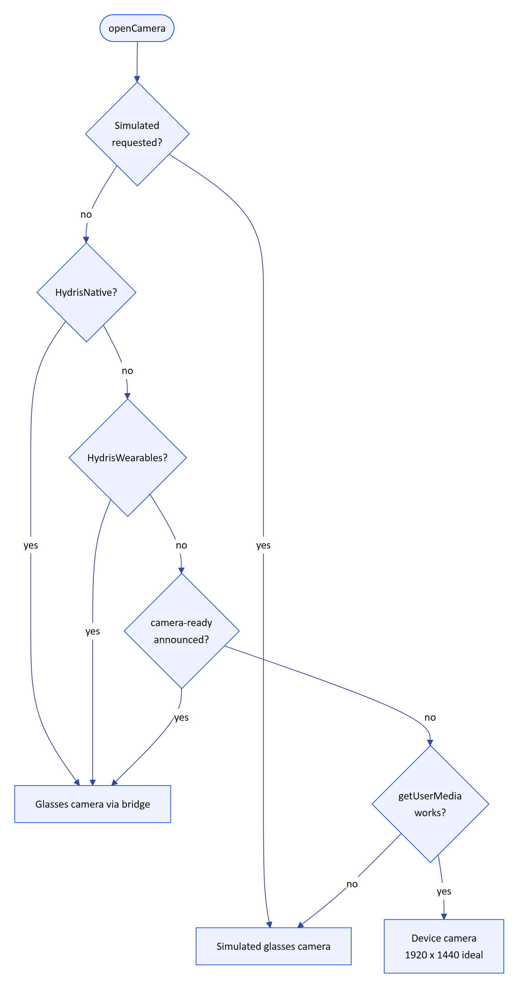
Figure 12. Camera source selection in openCamera()
The simulated camera draws the sample A4 audit sheet moving through too close, too far, tilted and finally square, so every guidance state is exercised without hardware. Its stills are 2016 x 1512.
WARNING
Bridge hardening is Planned: the WebView grants every page permission request (onPermissionRequest grants all resources) and does not restrict navigation away from HYDRIS_URL. The JavaScript interface would be exposed to any page loaded. Restrict navigation to the Hydris origin before distributing the bridge outside the team.

7 Glasses web viewport

7.1 HUD and phone modes
useViewportLayout in apps/web/src/glasses/hud.tsx picks the layout.
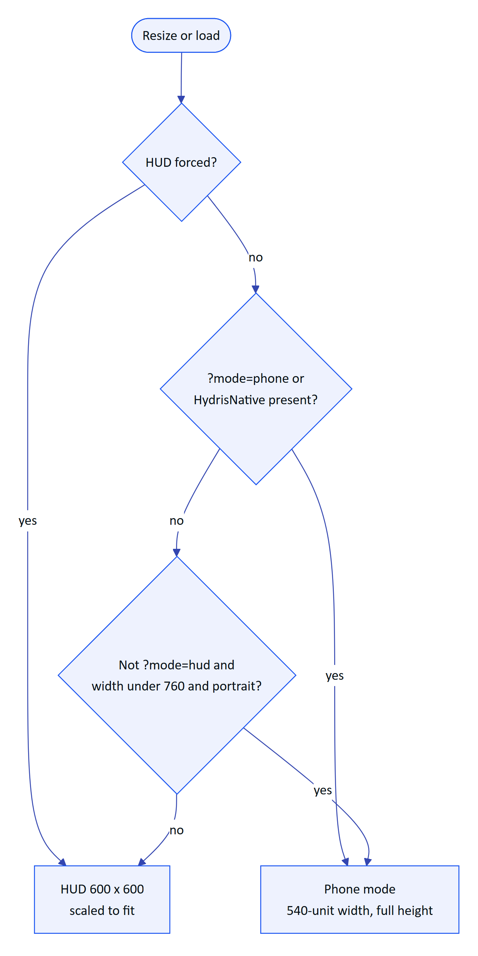
Figure 13. Choosing HUD or phone layout
Table 10. HUD versus phone mode
Aspect | HUD mode | Phone mode
Canvas | 600 x 600, scaled to the window | 540 design units wide, full device height
Target | Display glasses, simulator | Bridge app, portrait phones
Navigation | Directional keys, swipes, hydris:input; hint bar for the configured hand | Bottom tab bar: Home or Back, Scan, Hey Hydris, Alerts
Design rules | Additive display: black is transparent, light strokes, type at 20 px or more, a lime focus ring, one primary action per screen | Same components, safe-area insets

7.2 Phases and screens
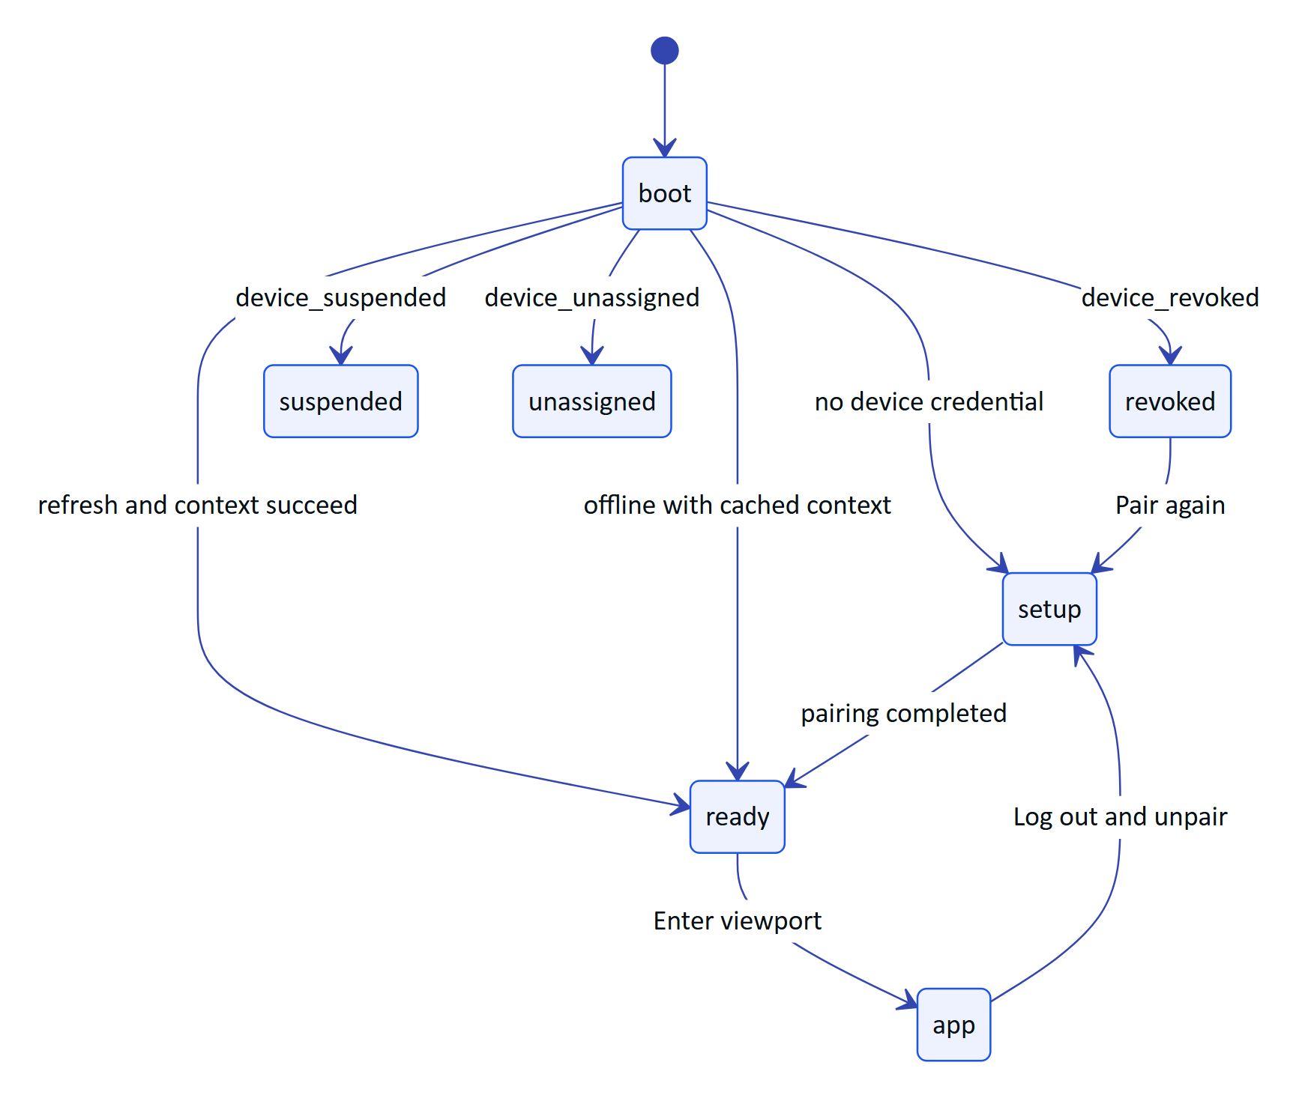
Figure 14. Viewport phases (GlassesApp.tsx)
Screens: home, alerts and alert detail, inspections and the inspection runner, tasks and task detail, asset context, assist, status, notifications, Hydris AI, plant map, audit scan, measurements, assets, SOP library and reader. Each screen is gated by the organization's UI profile (screenPermitted), so administrators decide in the console what each role sees on the glasses.

7.3 Voice assistant on the viewport
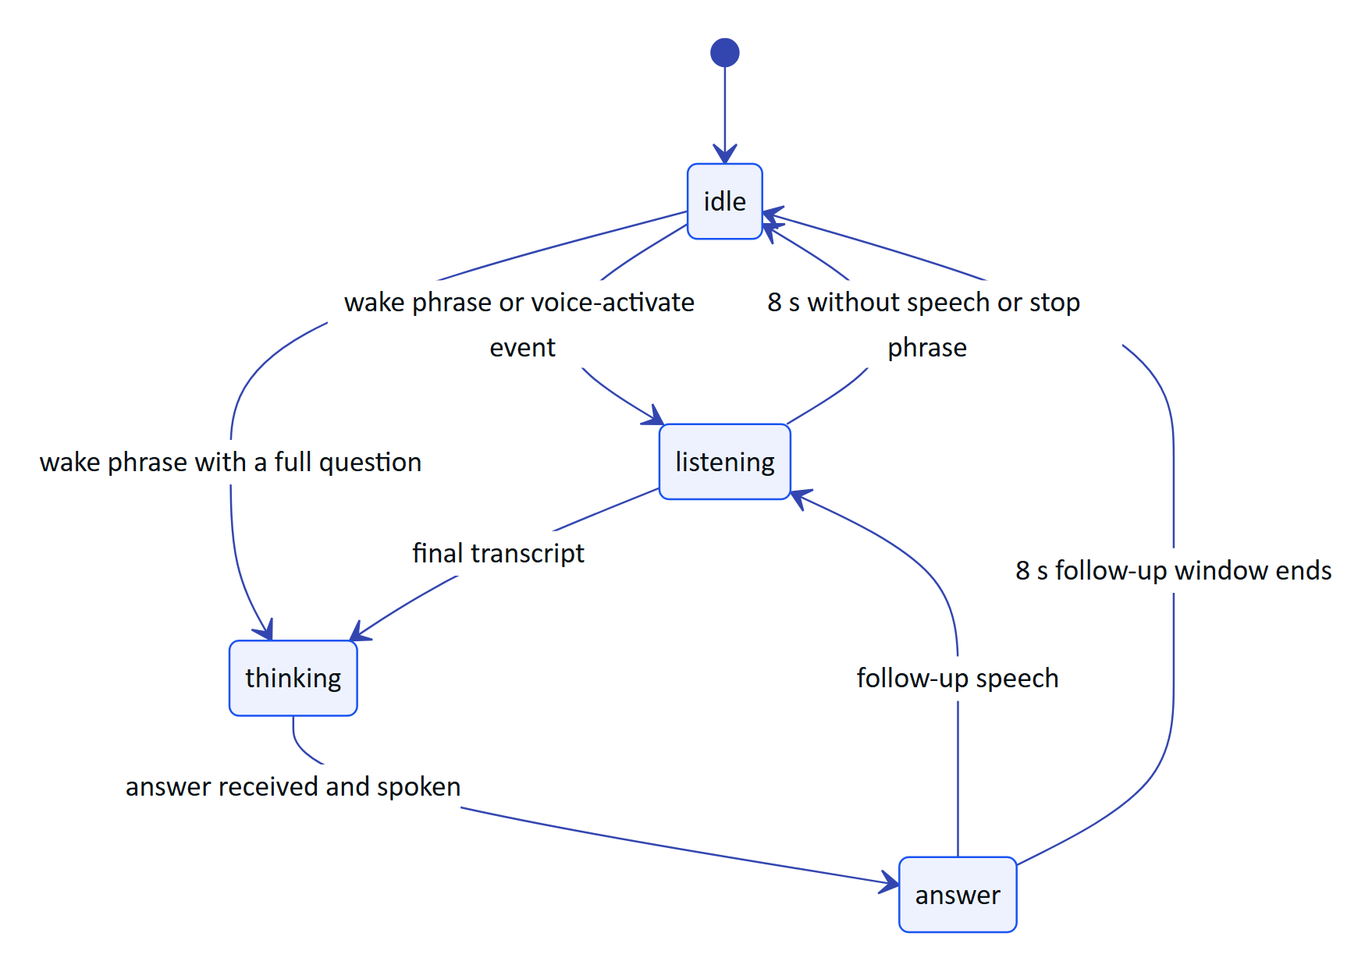
Figure 15. Hey Hydris on the viewport (VoiceAssistant.tsx)
The engine order is the bridge (meta-glasses), then the browser Web Speech API, then none (typed questions). Offline, demo and cached answers come from answerFromContext using the same rules as the API.

7.4 Audit scan on the viewport
AuditScan.tsx follows the same steps as the native app: guided capture (apps/web/src/lib/GuidedCapture.tsx, 900 ms ready time, stability threshold 0.012), A4 warp to 1654 px wide, two OCR passes in the browser, review of up to six pages and upload. The capture button shoots while framing and starts a scan from the menu or review.

8 Pairing with the Hydris account
Glasses become Hydris devices through an RFC 8628-style device authorization flow (apps/api/src/modules/devices.ts). Two variants exist.

8.1 Code and QR (viewport and bridge)
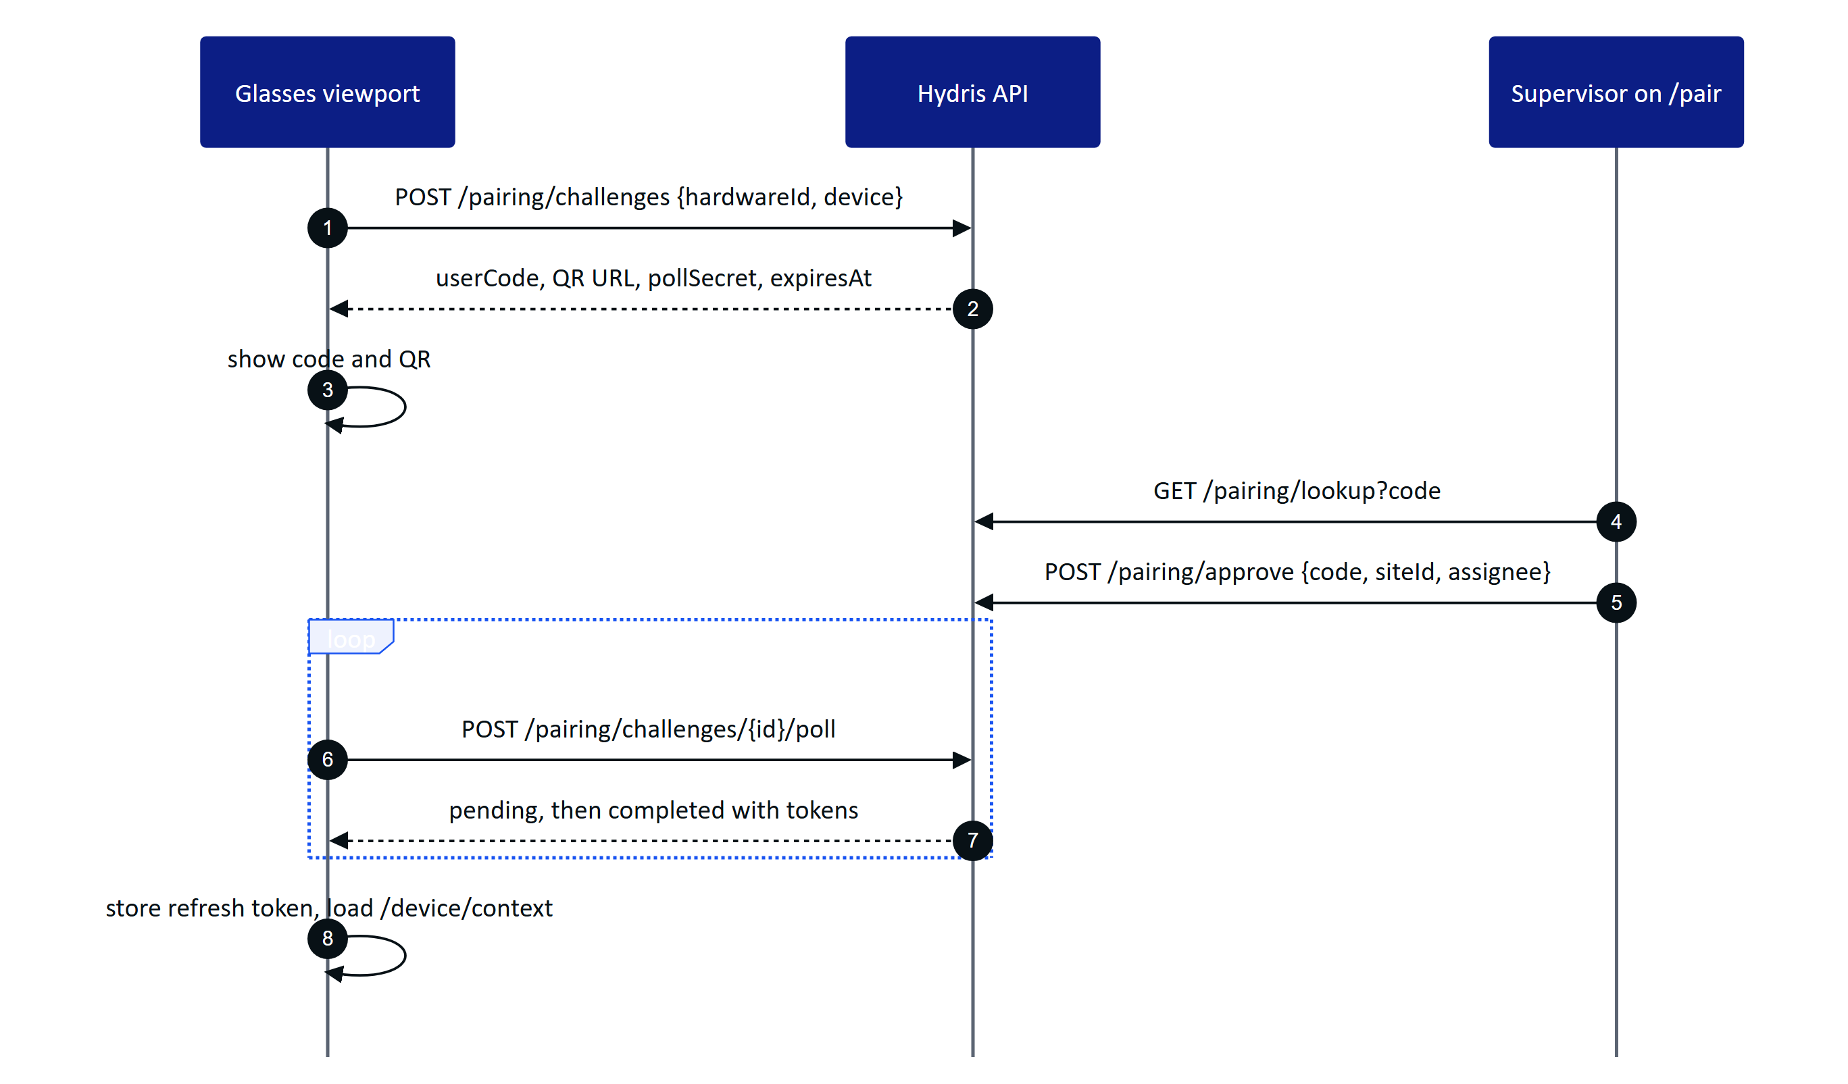
Figure 16. Pairing from the glasses viewport
The viewport's hardware ID is hg- plus a random UUID kept in local storage; the refresh token is stored in local storage too (link.ts), which the code marks as the integration boundary for a hardware-backed store.

8.2 Self-approval (native app)
The native app creates the challenge and approves it as the signed-in user in one step, assigning the glasses to that user and the first site the user can see. Its hardware ID is rbm- plus a SHA-256 digest of the DAT device identifier. Details are in the Mobile App Specification (HFG-MOB).
Table 11. Pairing rules and constants
Rule | Value
Code length and alphabet | 8 characters from 23456789ABCDEFGHJKMNPQRSTVWXYZ
Challenge lifetime | 300 s
Poll interval | 3 s; faster polls return slow_down
Statuses | pending, approved, completed, denied, expired, cancelled
Approver permission | device.pair; pairing to another person needs device.manage
Cross-organization | device_owned_elsewhere until revoked in the other organization
A new challenge for the same hardware | Cancels older pending or approved ones
Device states seen by the viewport | active, suspended, revoked, unassigned

9 Setup guide

9.1 Developer setup
- Create an organization and app in the Wearables Developer Center (confirm country eligibility).
- Install the Meta AI app on an Android 12 or later phone, sign in, pair the glasses and update the firmware.
- In the Meta AI app, open Settings, App Info, tap the version five times and turn on Developer Mode.
- Configure the GitHub Packages Maven repository for com.meta.wearable with a token that has read:packages.
- Set sdk.dir and hydris_url in local.properties; leave the DAT placeholders at 0 for Developer Mode.
- Build and install: ./gradlew assembleDebug, then adb install.
- Enable the experimental Speech, Inputs and Voice Invocations capabilities for the app in the Developer Center.

9.2 Operator setup (native app)
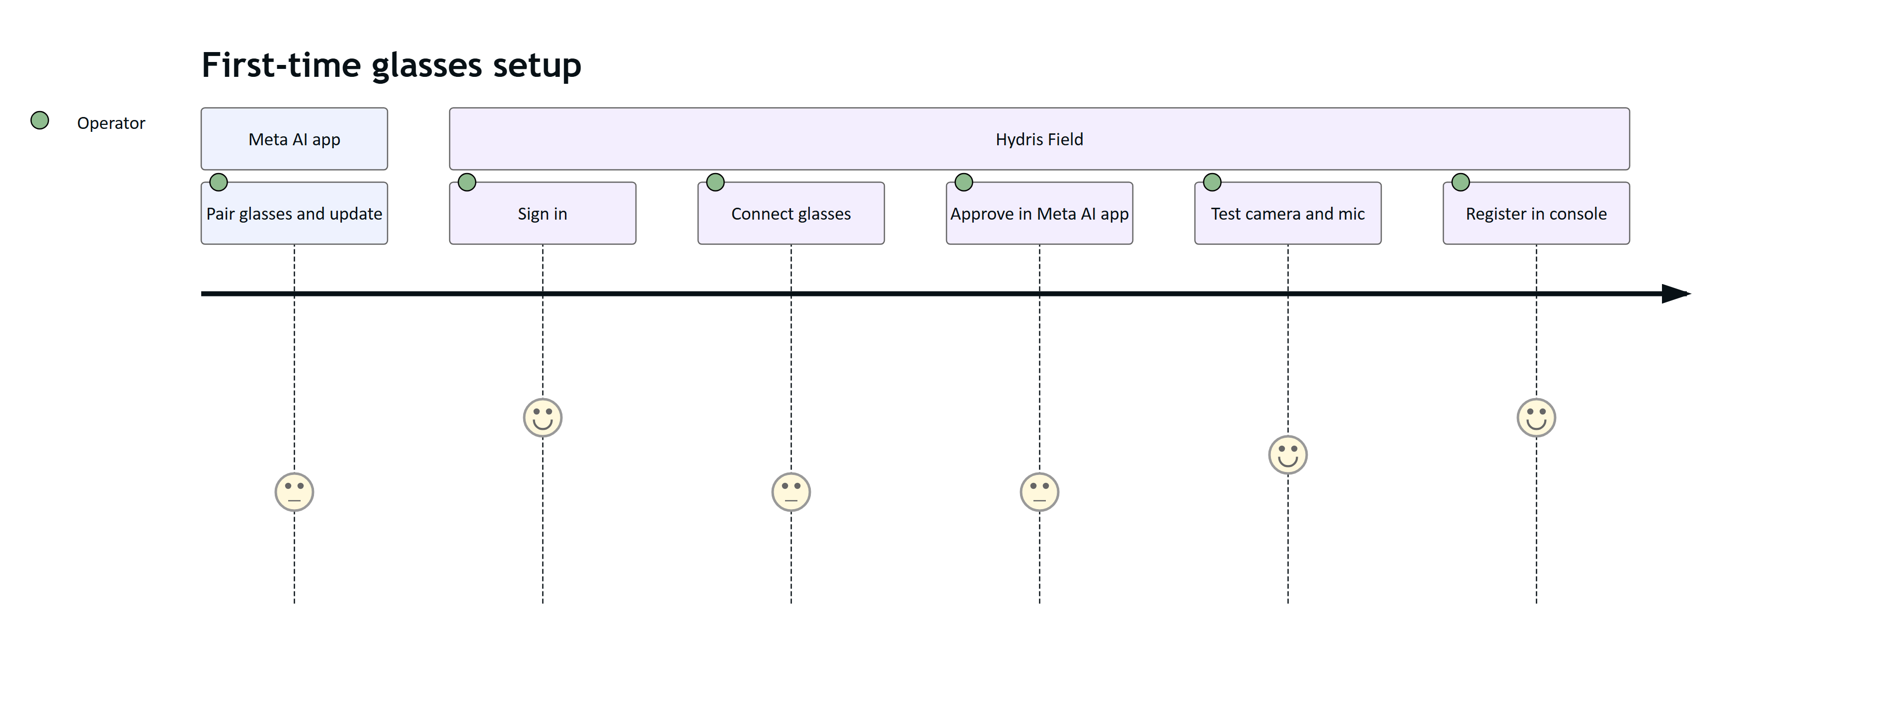
Figure 17. Operator setup journey
- Open Hydris Field, sign in and allow Bluetooth and notifications.
- Glasses tab, step 1: Connect glasses, approve Hydris in the Meta AI app, return.
- Step 2: Test camera and Test microphone, approving each in the Meta AI app the first time.
- Step 3: Register glasses. The glasses now appear in the console under Field glasses.
- Scan tab: Scan with glasses camera, or press the capture button.

10 Troubleshooting
Table 12. Troubleshooting
Symptom | Likely cause | Fix
"Install the Meta AI app and pair your glasses in it first" | Meta AI app missing | Install it, sign in, pair the glasses
Meta link stays "unavailable" | DAT not initialized (Bluetooth permission denied) | Allow Nearby devices for Hydris in Android settings, reopen the app
Connect does nothing or returns unregistered | Developer Mode off, or firmware below DAT requirements | Enable Developer Mode, update firmware in the Meta AI app
"Camera permission denied in Meta AI" | Prompt declined | Run Test camera again and approve, or change it in Meta AI app connections
"No glasses session" | Glasses off, out of range or connected elsewhere | Wake the glasses, keep them near the phone, retry
Preview is black or garbled | Stride inference wrong on this firmware | Report the device and firmware; use the phone camera meanwhile
Capture button ignored | Inputs not enabled for the app, or not on the scan screen | Enable Inputs in the Developer Center; open Scan
Hey Hydris uses the phone microphone | Glasses not registered or speech failed | Check step 1 and the microphone permission
Answers play on the phone speaker | Glasses not the Bluetooth audio output | Reconnect audio in Android Bluetooth settings
"Your account has no site to assign the glasses to" | User has no site access | Ask an admin for site access
device_owned_elsewhere | Glasses registered in another organization | Revoke them there first
Viewport shows "Device revoked" | Admin revoked the device | Pair again

11 Limitations and known gaps
- Not yet run on physical glasses; preview stride, capture press decomposition and speech restart are unverified.
- The DAT camera stream is not stopped when the preview ends (battery and capture LED impact).
- Preview frames reach the phone over the wireless link, so preview resolution and frame rate are far below on-glasses recording; detection runs on about 200 px frames and the photo is full resolution.
- The native app assigns registered glasses to the first available site.
- Voice Invocations are handled only by the bridge.
- deviceName() in the bridge is a constant.
- The bridge WebView needs navigation and permission hardening.
- Hardware gestures (Neural Band, temple touchpad) are not delivered to the web runtime; input.ts keeps a placeholder.
- The Mock Device Kit does not support display glasses (Meta FAQ), and Hydris has no automated DAT tests yet.
- Public publishing of DAT apps is not open yet (Meta FAQ); pilots rely on Developer Mode and release channels.
- Full Developer Center access is limited to countries where Meta AI glasses are supported.

12 Glasses state model and console view

12.1 GlassesState fields
GlassesManager.state is the single source of truth the native UI reads. Every field is written by DAT callbacks or by Hydris's own calls, never by the screens.
Table 13. GlassesState fields (glasses/GlassesManager.kt)
Field | Type | Written by | Shown as
initialized | Boolean | initialize() | Gates the Connect button (initializes on demand)
registration | Text | registrationState collector | "Meta link: ..." on the status card
registered | Boolean | registrationState is REGISTERED | Step 1 done, Home tile text, Scan menu subtitle
devices | List of IDs | Wearables.devices | Status dot colour; input to the hardware ID
deviceName | Text | devicesMetadata (fallback "Ray-Ban Meta") | Card title, scan chip, registration name
session | Text | Session state collector | "session: ..." on the status card
cameraStreaming | Boolean | Camera stream state after start | "camera live" chip, step 2 done
speech | Text | Speech state collector | "mic listening" chip, step 2 done
lastError | Text | fail() | Error note on the Glasses screen
log | List, latest 30 | log() and fail() | Connection log card (latest 8)

Separate flows carry the data path: frame (latest preview bitmap), captureButton (short presses) and speech (transcripts with the final flag). The shared flows have small extra buffers (4 presses, 16 transcripts) so a slow collector drops nothing in normal use.

12.2 What the console sees
Once registered, the glasses are an ordinary Hydris device record. The console's Field glasses page lists them with status, assignment, site, last seen time and app version; supervisors can assign, suspend or revoke them. Scans uploaded with the device token are attributed to the device. Domain events device.paired and device.updated are published on the realtime bus with the device.read permission, so open consoles update live.
Table 14. Device records created by each runtime
Runtime | Kind | Model | Hardware ID | App version reported
Native app | hardware | "Ray-Ban Meta" | rbm- plus SHA-256 prefix | android-1.0.0
Bridge viewport | hardware | "Web viewport" | hg- plus random UUID | 0.2.0
Simulator viewport | simulator | "Hydris browser simulator" | hg- plus random UUID | 0.2.0

NOTE
The same physical glasses paired once through the native app and once through the bridge produce two device records, because the hardware IDs are derived differently. Pilots should use one runtime per pair of glasses. Unifying the ID is Planned.

13 Data flows and network use
Table 15. What crosses which link
Data | Glasses to phone | Phone to Hydris | Notes
Preview frames | Raw YUV over the Meta link | Never | Luma only, processed in memory
Page photo | Bitmap or HEIC | JPEG under 850 KB per page, only on "Send" | Two OCR readings attached
Speech | Transcripts from DAT | Question text only | Audio is not sent to Hydris
Spoken answers | Phone TTS over Bluetooth audio | Answer text received from /assistant/ask
Capture button | Input events | Never
Device identifier | DAT device ID | SHA-256 derived hardware ID | Native app only

Table 16. Timing targets for the first hardware run (targets, not measured)
Path | Target
First preview frame after opening the glasses scan | Under 3 s with an existing session
Preview rate reaching detection | 8 to 10 frames per second
Photo returned after capture | Under 4 s
Wake phrase to listening card | Under 1 s after the transcript arrives
Speech restart gap after silence | Under 1 s

Results will be recorded in the QA test plan (HFG-QA).

14 Hardware acceptance tests
The first hardware run must answer the open questions in this document. Failures become issues against GlassesManager.kt or the bridge.
Table 17. Hardware test checklist
ID | Test | Expected result
GLS-T01 | Connect glasses with the Meta AI app installed and Developer Mode on | Meta AI app opens, approval returns to Hydris, Meta link "registered"
GLS-T02 | Connect with Developer Mode off | Clear error from DAT shown, no crash
GLS-T03 | Test camera, first time | Meta AI permission prompt, then "Glasses camera is streaming"
GLS-T04 | Guided scan of an A4 sheet on a dark desk | Preview correct (not sheared), guidance changes, auto-capture within 10 s of a steady pose
GLS-T05 | Leave the scan screen | Preview stops; record whether the capture LED and stream stay on
GLS-T06 | Capture photo in different head poses | Bitmap upright after EXIF rotation
GLS-T07 | Short press of the capture button on the Scan menu | Glasses scan starts
GLS-T08 | Long press of the capture button | Ignored by Hydris; record what DAT reports
GLS-T09 | Hey Hydris through the glasses microphone for 10 minutes | Listening resumes after each silence; no transcripts of Hydris's own answers
GLS-T10 | Answer playback | Speech heard on the open-ear speakers
GLS-T11 | Register glasses | Device appears in the console with the right name and site
GLS-T12 | Revoke the device in the console, then upload a glasses scan | Upload fails with a clear message; Unregister clears local tokens
GLS-T13 | Turn the glasses off mid-session | Session stops, state resets, next scan recreates the session
GLS-T14 | Bridge: tests T03 to T10 inside the WebView | Same results through the JavaScript bridge
GLS-T15 | Battery over a simulated four-hour shift with periodic scans and Hey Hydris on | Recorded for phone and glasses

15 Frequently asked questions
Can an operator use Hydris without the Meta AI app? Yes, without glasses. Every glasses feature has a phone fallback: the phone camera, microphone and speaker. With Ray-Ban Meta or Oakley Meta glasses, the Meta AI app is mandatory.
Why does Hydris need its own pairing when the glasses are already paired in the Meta AI app? The Meta AI app pairs the glasses to the phone. Hydris pairing makes the glasses a managed device in the customer's organization: assigned to a person and a site, visible to supervisors, revocable, and credited for the scans it captures.
Why not run Hydris as a Web App on Meta Ray-Ban Display? Meta's Web Apps cannot use the camera or capture microphone audio, so audit scans and Hey Hydris on the glasses microphone need a phone app with DAT. A Web App could still show the HUD, which is a Planned option.
Does Hydris record video? No. It uses preview frames in memory for framing and takes single photos of documents.
Which runtime should a pilot use? The native Hydris Field app. The bridge exists for the web viewport and for development comparison; it is not planned for general distribution.
Can one phone serve several pairs of glasses? DAT selects a device with AutoDeviceSelector. Hydris assumes one pair per phone and uses the first device it sees.

16 Privacy
IMPORTANT
Glasses cameras raise bystander concerns in plants. Hydris keeps capture deliberate, local and visible.

- Deliberate capture. The glasses camera runs only on the Scan screen or the camera test. Photos are taken by auto-capture after the page is aligned, by "Capture now" or by the capture button. There is no background recording and no video upload.
- Capture LED. Meta glasses show a capture LED when the camera is in use; Hydris cannot and does not try to control it. Whether the LED is lit during DAT preview streaming is to be confirmed on hardware.
- On-device processing. Page detection and both OCR passes run on the phone. Images leave the phone only when the operator taps "Send for verification".
- Minimal identifiers. The raw DAT device identifier is hashed before it reaches Hydris.
- Audio. Glasses speech is recognized through DAT; Hydris receives transcripts, not audio, and sends only the question text to /assistant/ask.
- Bystanders. Pilot sites should brief staff, mark scan points, and avoid scanning near people; scans target A4 documents and the warp crops to the page.
- Retention and access. Scans follow the audit document retention and permissions described in the Security and Privacy document (HFG-SEC).

17 Roadmap
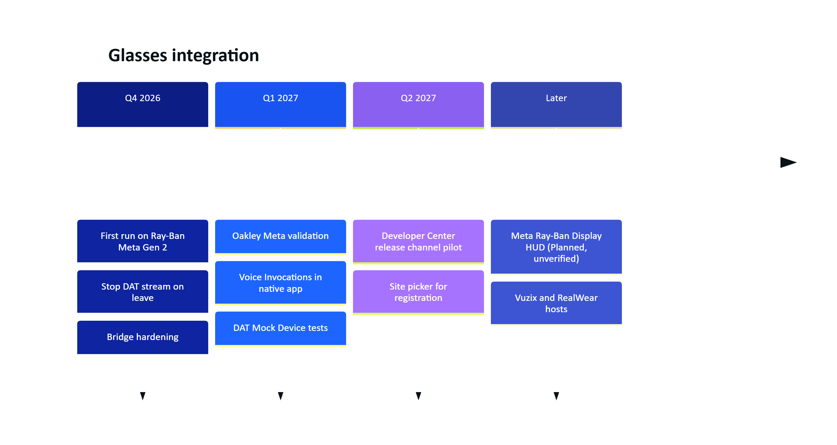
Figure 18. Glasses integration roadmap (indicative)
Table 18. Planned display work
Item | Status | Basis
Use the display of Meta Ray-Ban Display through DAT | Planned, unverified | Meta's documentation index says DAT apps can use "the display on Meta Ray-Ban Display glasses"; the API details are not yet reviewed
Run the viewport as a Web App on Meta Ray-Ban Display | Planned, unverified | Meta Web Apps run in a Chromium-based browser on the glasses over HTTPS; they cannot use the camera or capture microphone audio, and receive speech only as dictated text or WebMCP tool calls
Native device adapter for display glasses with neural band input | Planned | Listed on the Hydris website roadmap (apps/web/src/site/content.ts)
Vuzix M400 and RealWear Navigator 520 | Planned | Device records in demo data only

Audit scans from glasses will always need a phone app with DAT, because Web Apps cannot use the camera.

